Pig Exercise 2

Bài 1: List All employee records 4

Bài 2: List unique Job titles from EMP data 6

Bài 3: List employee records in desc order of their emp nbr 8

Bài 4: List employee records in desc order of their salaries 9

Bài 5: List employees in asc order of dept nbr. & desc of job title 11

Bài 6: List all employees with details of all ‘Managers’ 13

Bài 7: List all the unique job title in a descending order 15

Bài 8: List all employee/s who joined before 1981 17

Bài 9: List Empno, Ename, Sal, Daily Sal of all Employees in ascending order of AnnSal 19

Bài 10: List Empno, Ename, Job, Hiredate, Experience of all Managers 21

Bài 11: List Empno, Ename, Sal, Exp of all Employees working for Manager 7839 23

Bài 12: List details of Employees whose Commission is more than their salary 25

Bài 13: List Employees in ascending order of Designations 27

Bài 14: List Employees along with their experience & daily salary is more than $100 28

Bài 15: List Employees who are either ‘CLERK’ or ‘ANALYST’ in descending order 30

Bài 16: List Employees who joined on 1-May-81, 31-Dec-81, 17-Dec-81, 19-Jan-81 32

Bài 17: List Employees who are working for the deptno 10 or 20 33

Bài 18: List Employees who are joined in the year 1981 35

Bài 19: List Employees who are joined in the month of Dec 1981 37

Bài 20: List Employees whose annul salary is ranging from 22000 and 45000 39

Bài 21: List Employees those are having five characters in their names 41

Bài 22: List total sales per departmental store wise and consumer wise 43

Bài 23: How to handle Nulls in data (workaround) 45

Bài 24: 24 List Odd or Even Employee records based on empno 47

Bài 25: List Employee names starting with ‘S’ and having five 49

characters 49

Bài 26: List Employee names with 3rd character as ‘R’ and Four characters length 51

Bài 27: List Employee names starting with 'S' and ending 'H' with 5 characters length 53

Bài 28: List all employees who were joined in January 55

Bài 29: List employees who joined in a month of which second character is ‘a’ 57

Bài 30: List employees whose salary is 4 digit number ending with zero 58

Bài 31: List employees whose names have a ‘LL’ characters together 60

Bài 32: List employees who does not belong to deptno 20 62

Bài 33: List all employees except ‘President’ & ‘Manager’ in asc order of salaries 64

Bài 34: List all employees who joined in Before or After 1981 66

MapReduce 67

**Pig Eval Functions** **68**

Val 68

FOREACH 69

Bad To String 71

CONCAT 72

COUNT 74

COUNT STAR 75

DIFF 77

isEmpty 79

Max/Min 80

Chuẩn bị file dữ liệu tbl_EMP.txt



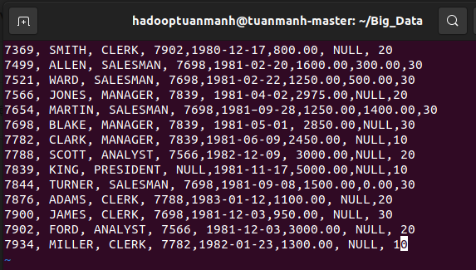

Kiểm tra xem đã có trên hdfs hay chưa

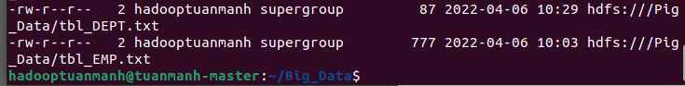

## Bài 1: [List All employee records](http://howt2talkt2apachepig.blogspot.com/2016/01/1-fetch-all-employee-records-with.html)

1. Local

* Tạo file ex1.pig



Thêm nội dung vào file như sau:

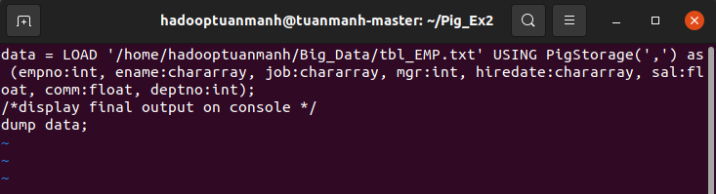

Chạy pig local



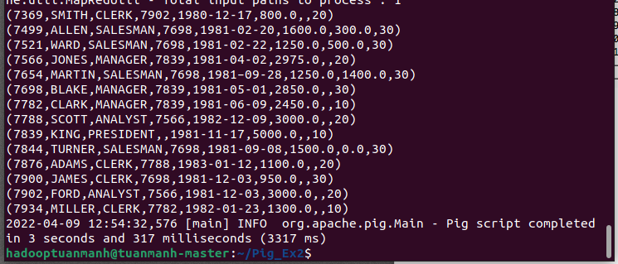

1. MapReduce

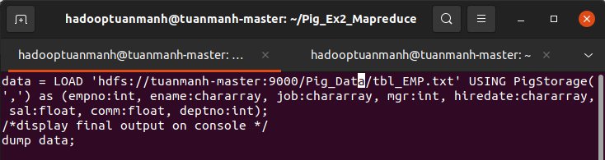

Chạy pig mapreduce

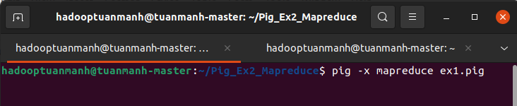

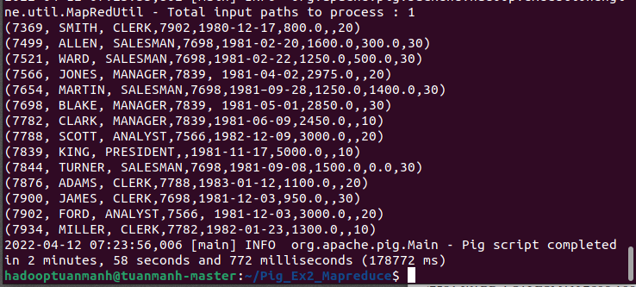

## Bài 2: [List unique Job titles from EMP data](http://howt2talkt2apachepig.blogspot.com/2016/01/2-fetch-only-unique-job-positions-from.html)

1. Local

* Tạo file ex2.pig



Nhập nội dung như bên dưới:

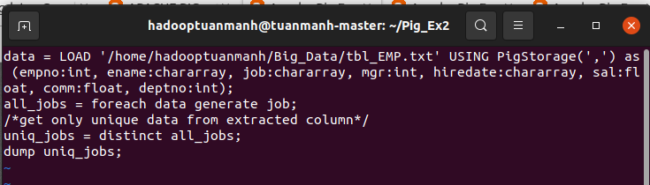

Chạy pig local



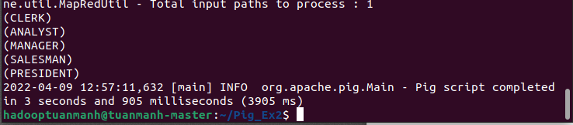

1. MapReduce

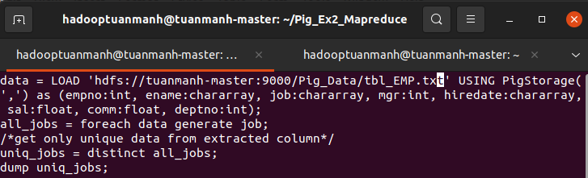

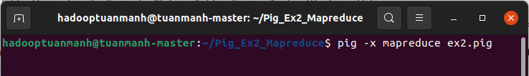

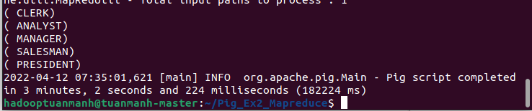

## Bài 3: [List employee records in desc order of their emp nbr](http://howt2talkt2apachepig.blogspot.com/2016/01/3-list-all-employee-records-in-asc.html)

1. Local

* Tạo file ex3.pig



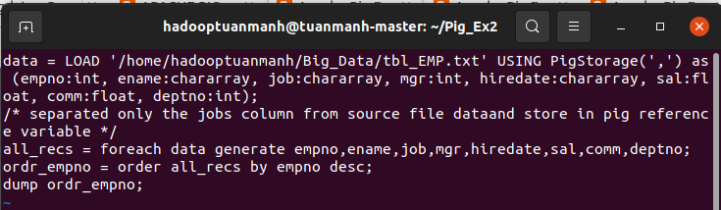

Chạy pig local



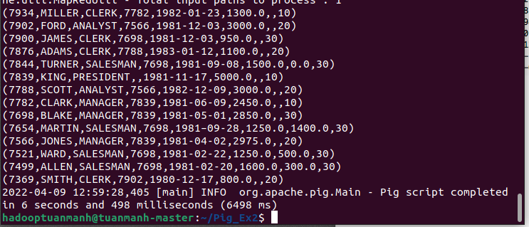

1. MapReduce

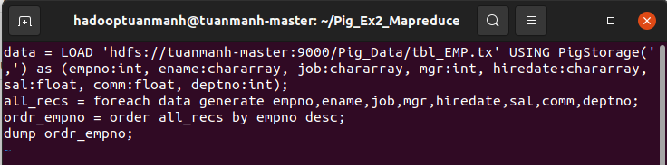

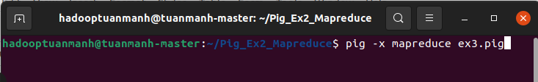

Kết quả

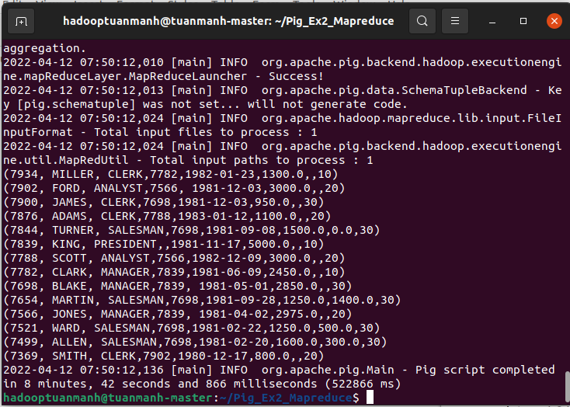

## Bài 4: [List employee records in desc order of their salaries](http://howt2talkt2apachepig.blogspot.com/2016/01/4-fetch-list-all-employee-records-in.html)

1. Local

* Tạo file ex4.pig



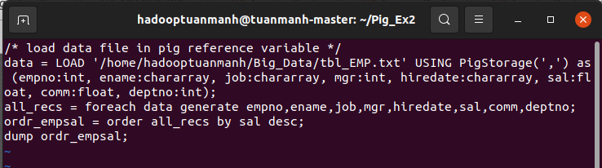



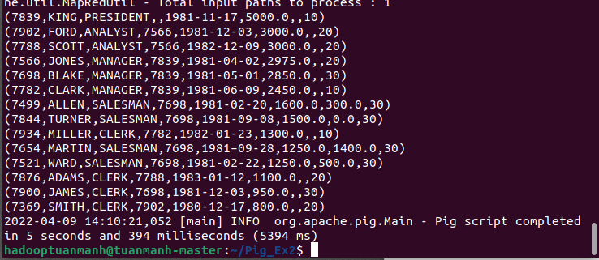

1. MapReduce

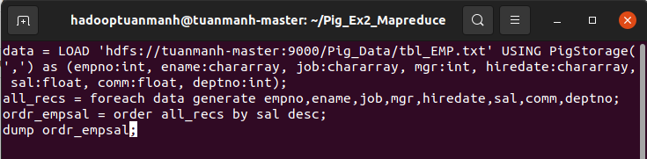

Chạy pig mapreduce

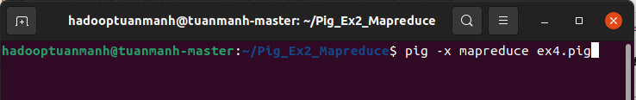

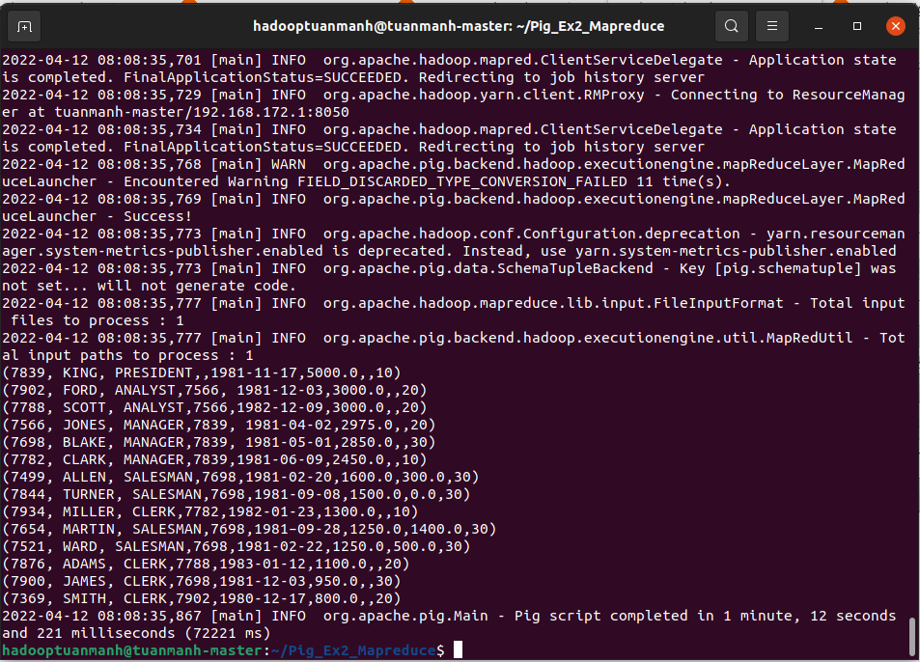

## Bài 5: [List employees in asc order of dept nbr. & desc of job title](http://howt2talkt2apachepig.blogspot.com/2016/01/5-list-all-employee-records-in-asc.html)

1. Local

* Tạo file ex5.pig



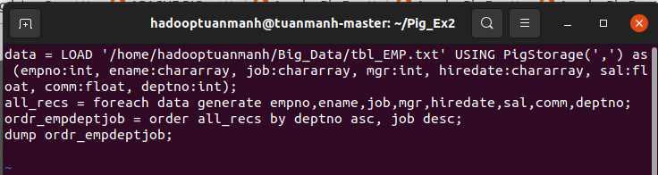



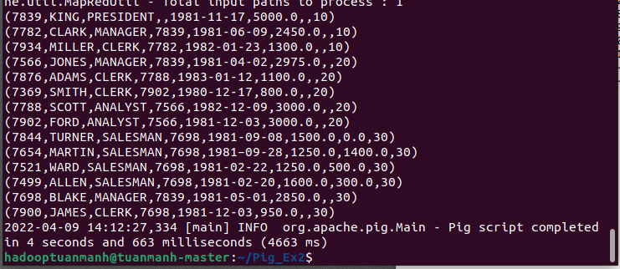

1. MapReduce

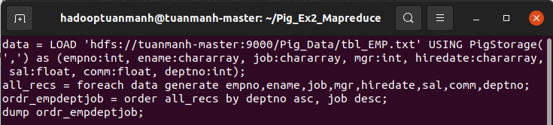

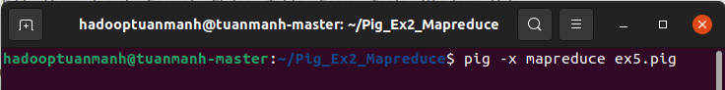

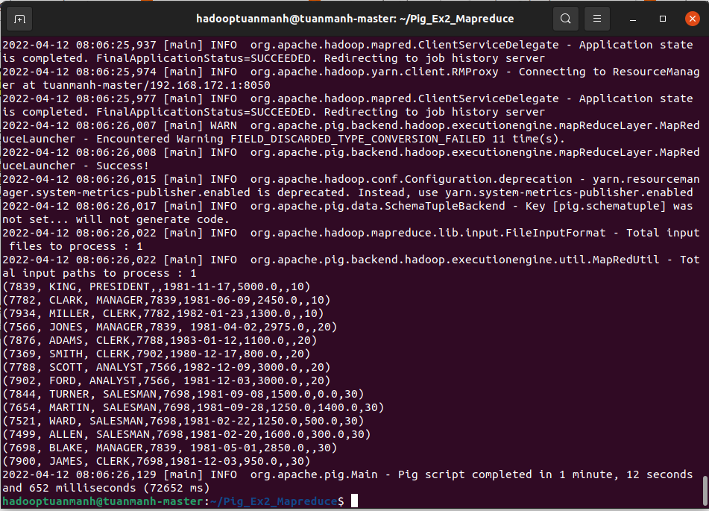

## Bài 6: [List all employees with details of all ‘Managers’](http://howt2talkt2apachepig.blogspot.com/2016/01/8-display-details-of-all-mgrs.html)

1. Local

* Tạo file ex6.pig



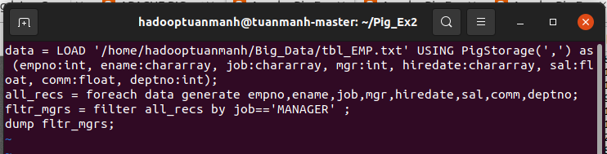



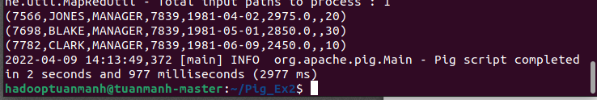

1. MapReduce

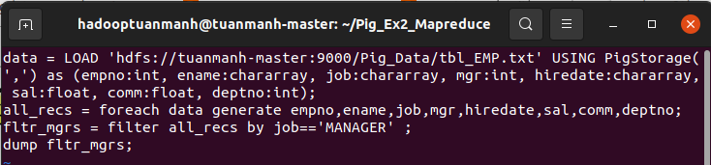

Run mapreduce pig

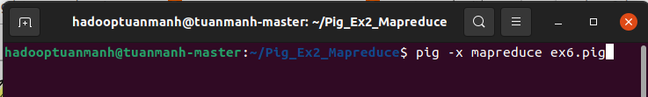

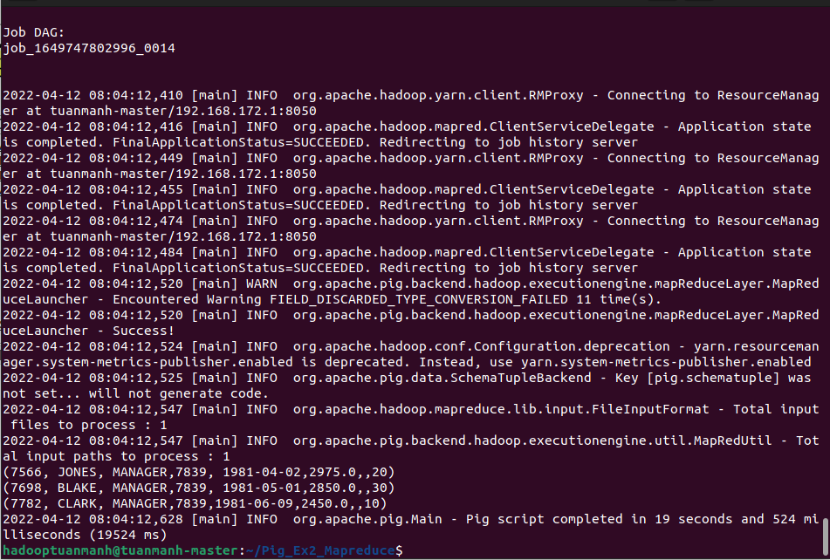

## Bài 7: [List all the unique job title in a descending order](http://howt2talkt2apachepig.blogspot.com/2016/01/7-display-all-unique-job-title-in.html)

1. Local

* Tạo file ex7.pig



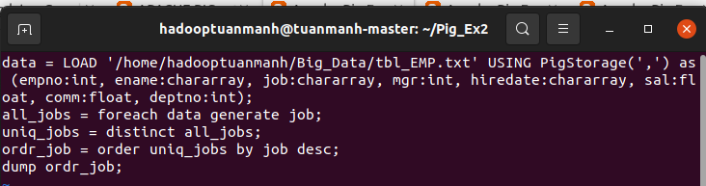

Run local mode



Kết quả:

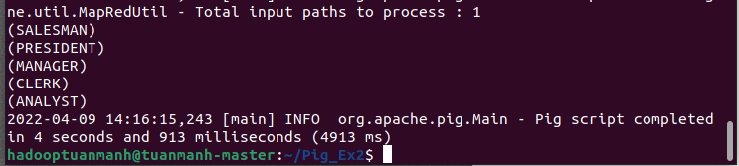

1. MapReduce

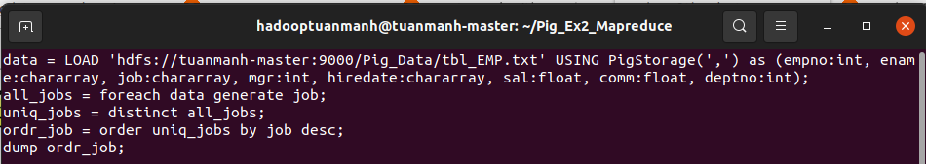

Run mapreduce mode



Kết quả phía dưới:

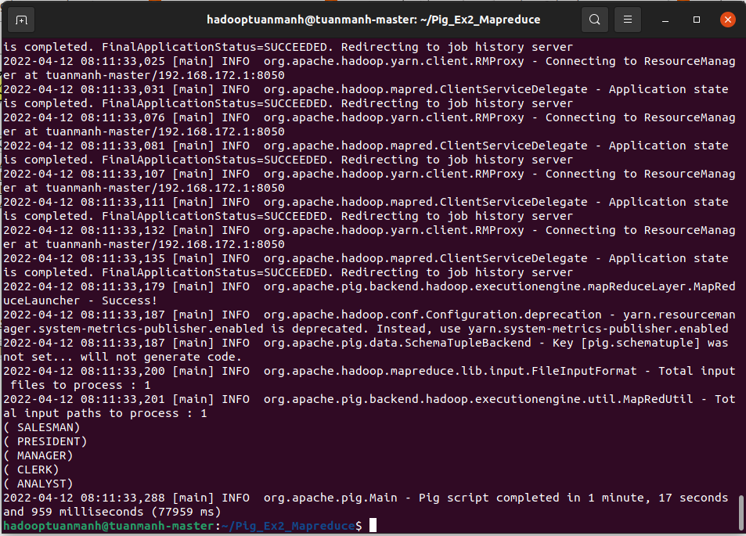

## 

## Bài 8: [List all employee/s who joined before 1981](http://howt2talkt2apachepig.blogspot.com/2016/01/6-list-details-of-all-managers.html)

1. Local

* Tạo file ex8.pig



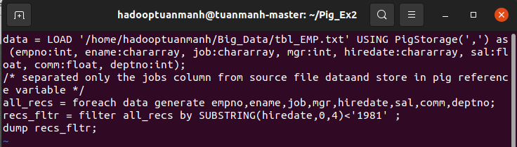

Run local mode



Kết quả:

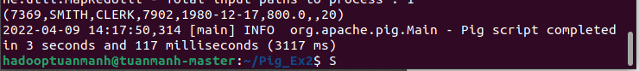

1. MapReduce

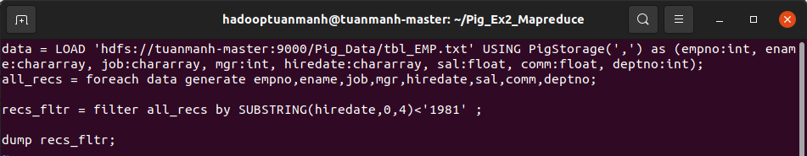

Run mapreduce mode

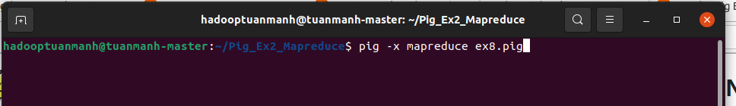

Kết quả phía dưới:

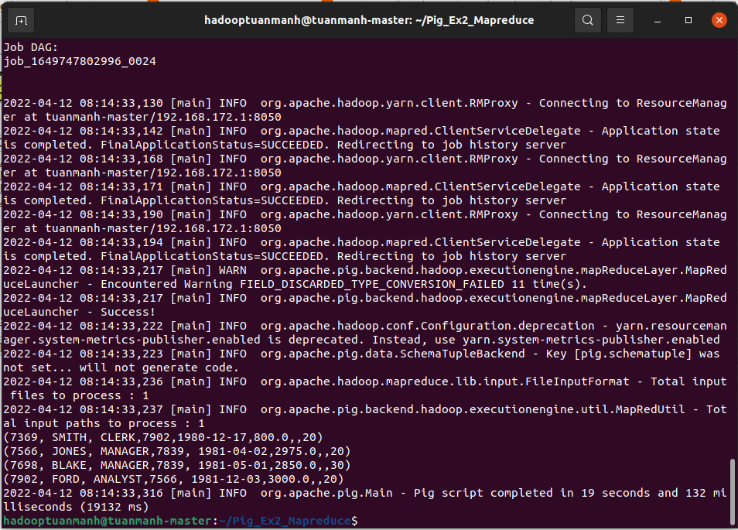

## Bài 9: [List Empno, Ename, Sal, Daily Sal of all Employees in ascending order of AnnSal](http://howt2talkt2apachepig.blogspot.com/2016/01/9-list-emps-who-joined-before-1981.html)

1. Local

* Tạo file ex9.pig



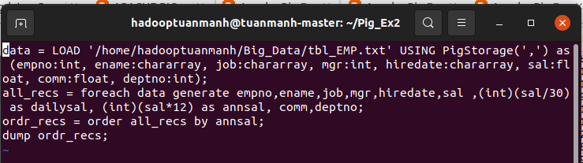

Run local mode



Kết quả:

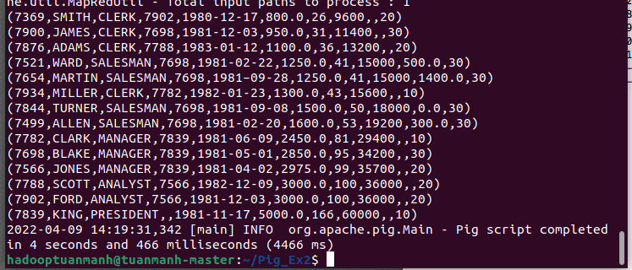

1. MapReduce

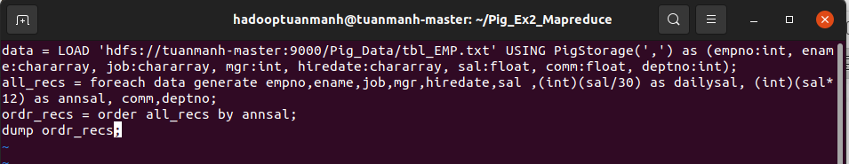

Run mapreduce mode



Kết quả:

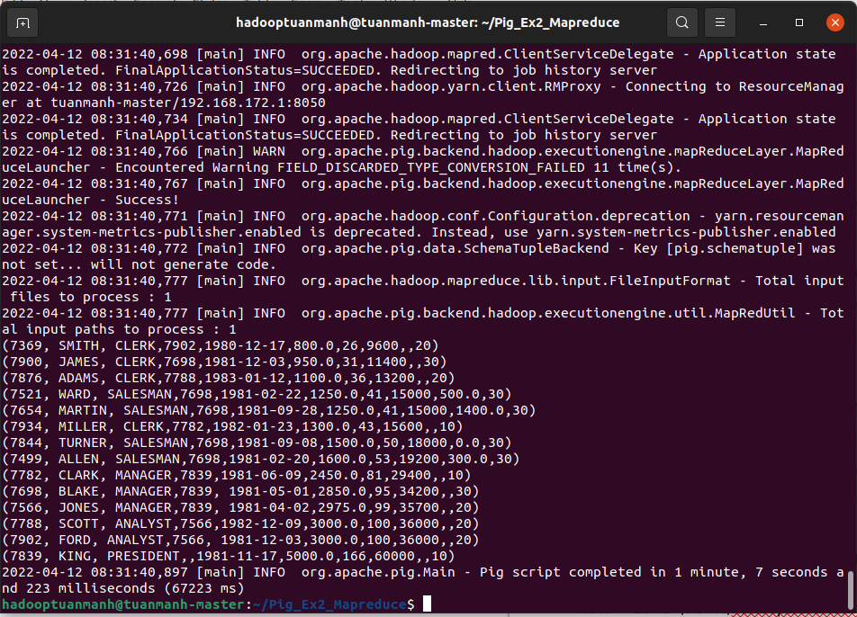

## Bài 10: [List Empno, Ename, Job, Hiredate, Experience of all Managers](http://howt2talkt2apachepig.blogspot.com/2016/01/10-list-empno-ename-sal-daily-sal-of.html)

1. Local

* Tạo file ex10.pig



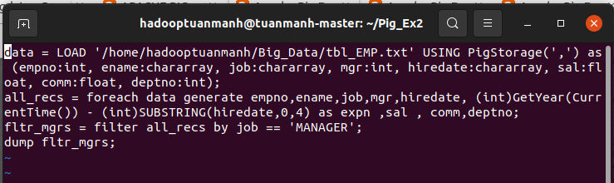



Kết quả:

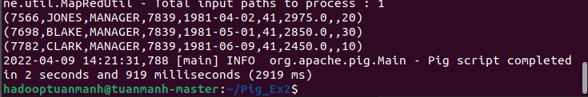

1. MapReduce

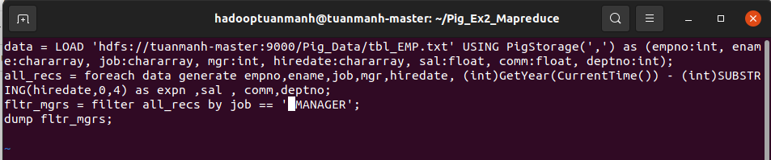

* Run mapreduce mode



Kết quả phía dưới:

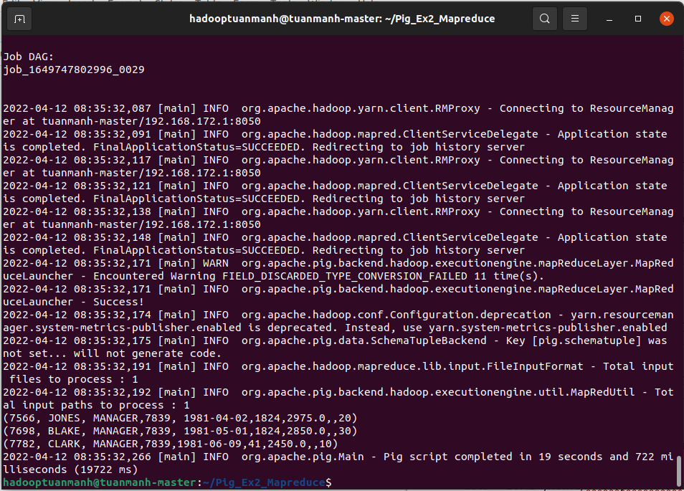

## Bài 11: [List Empno, Ename, Sal, Exp of all Employees working for Manager 7839](http://howt2talkt2apachepig.blogspot.com/2016/01/11-display-empno-ename-job-hiredate-exp.html)

1. Local

* Tạo file ex11.pig



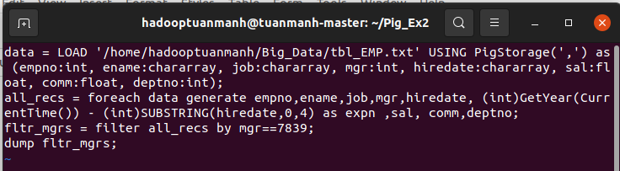

Run local mode



Kết quả

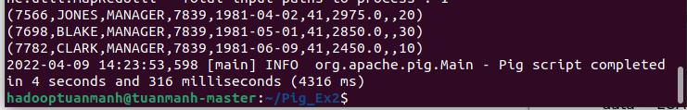

1. MapReduce

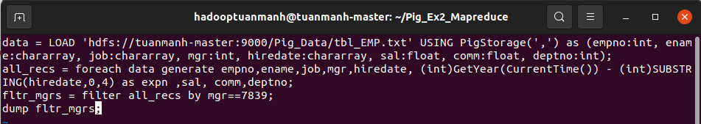

Chạy mapreduce mode



Kết quả phía dưới:

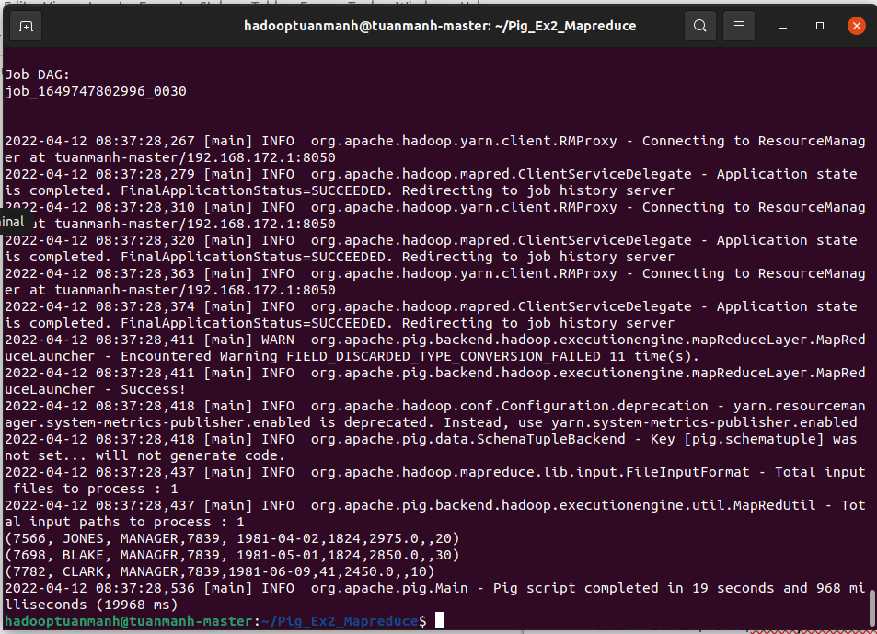

## Bài 12: [List details of Employees whose Commission is more than their salary](http://howt2talkt2apachepig.blogspot.com/2016/01/12-list-empno-ename-sal-exp-of-all-emps.html)

1. Local

* Tạo file ex12.pig

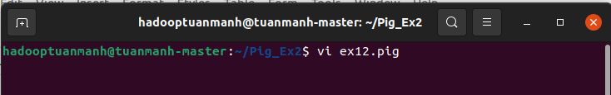

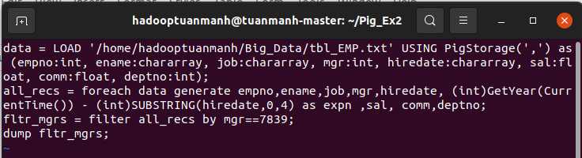



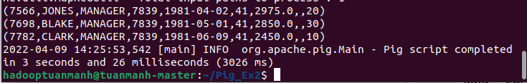

1. MapReduce

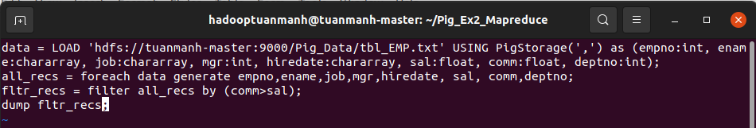



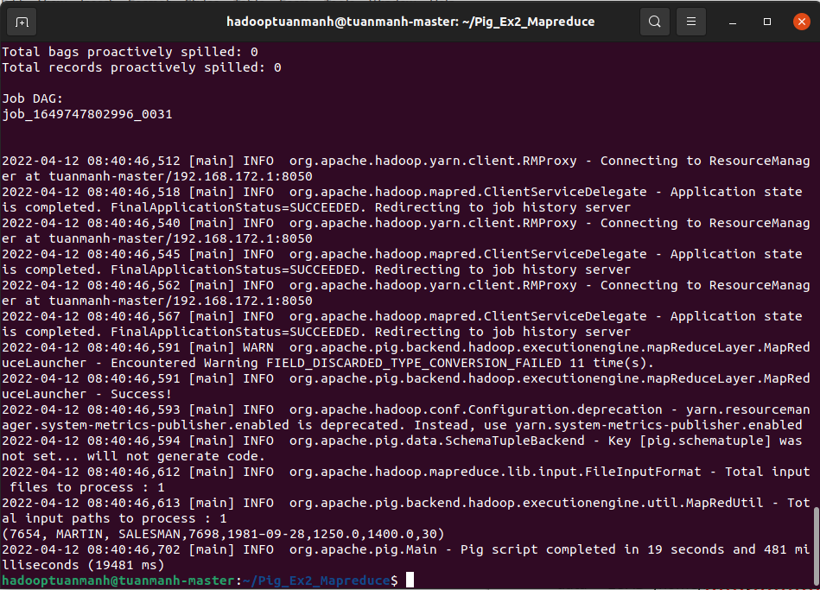

## Bài 13: [List Employees in ascending order of Designations](http://howt2talkt2apachepig.blogspot.com/2016/01/13-display-details-of-emps-whose-comm.html)

1. Local

* Tạo file ex13.pig



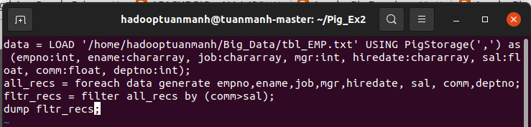



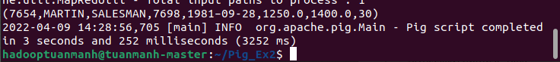

1. MapReduce

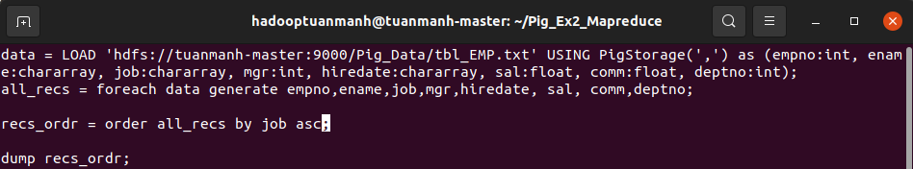



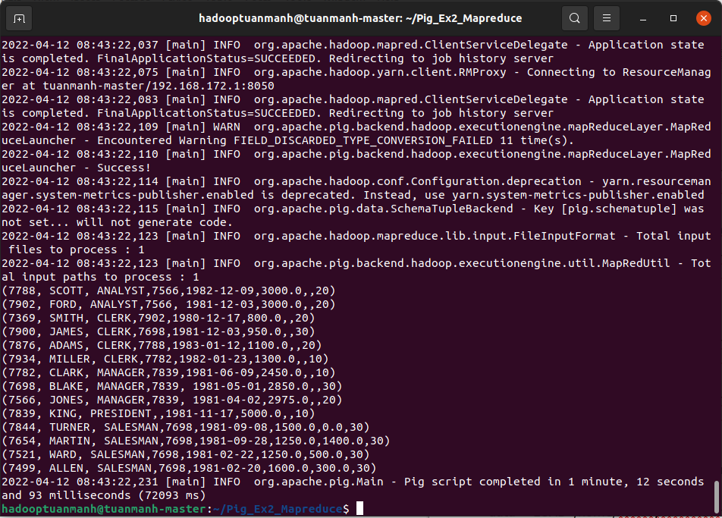

## 

## Bài 14: [List Employees along with their experience & daily salary is more than $100](http://howt2talkt2apachepig.blogspot.com/2016/01/14-list-emps-in-asc-order-of.html)

1. Local

* Tạo file ex14.pig



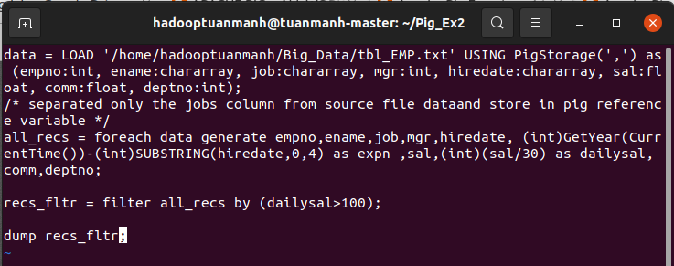



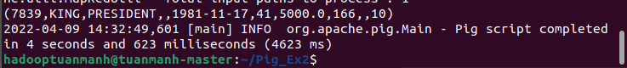

1. Mapreduce

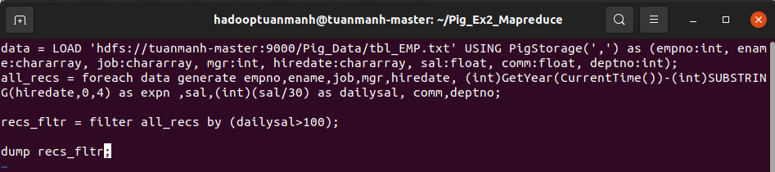



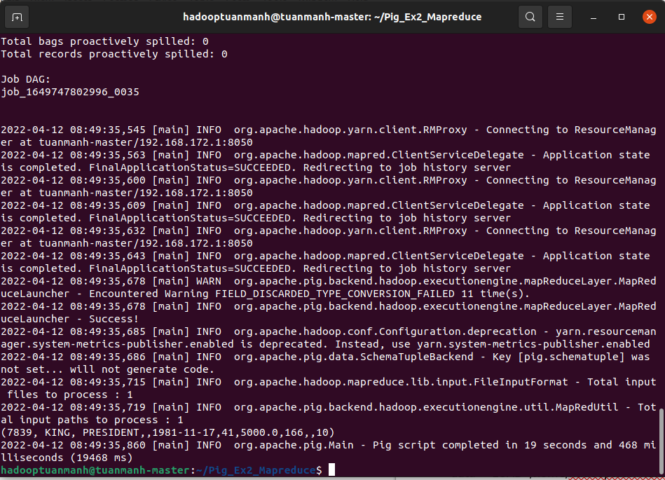

## Bài 15: [List Employees who are either ‘CLERK’ or ‘ANALYST’ in descending order](http://howt2talkt2apachepig.blogspot.com/2016/01/15-list-emps-along-with-their-exp-and.html)

1. Local

* Tạo file ex15.pig



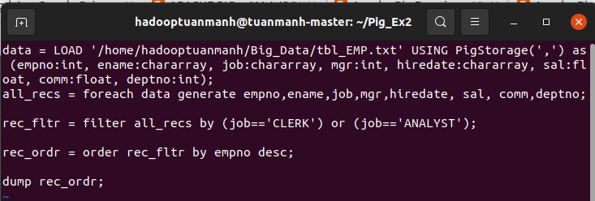

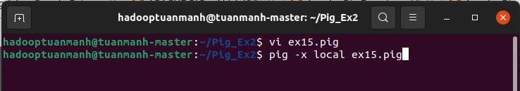

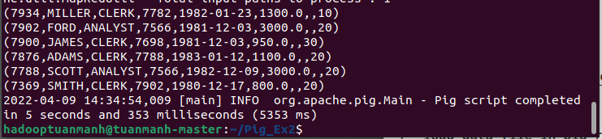

1. MapReduce

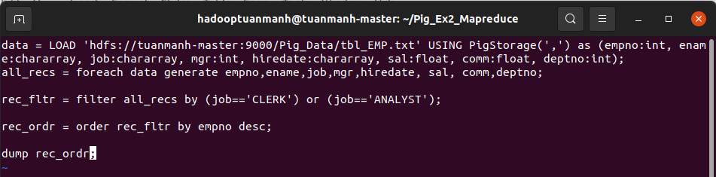



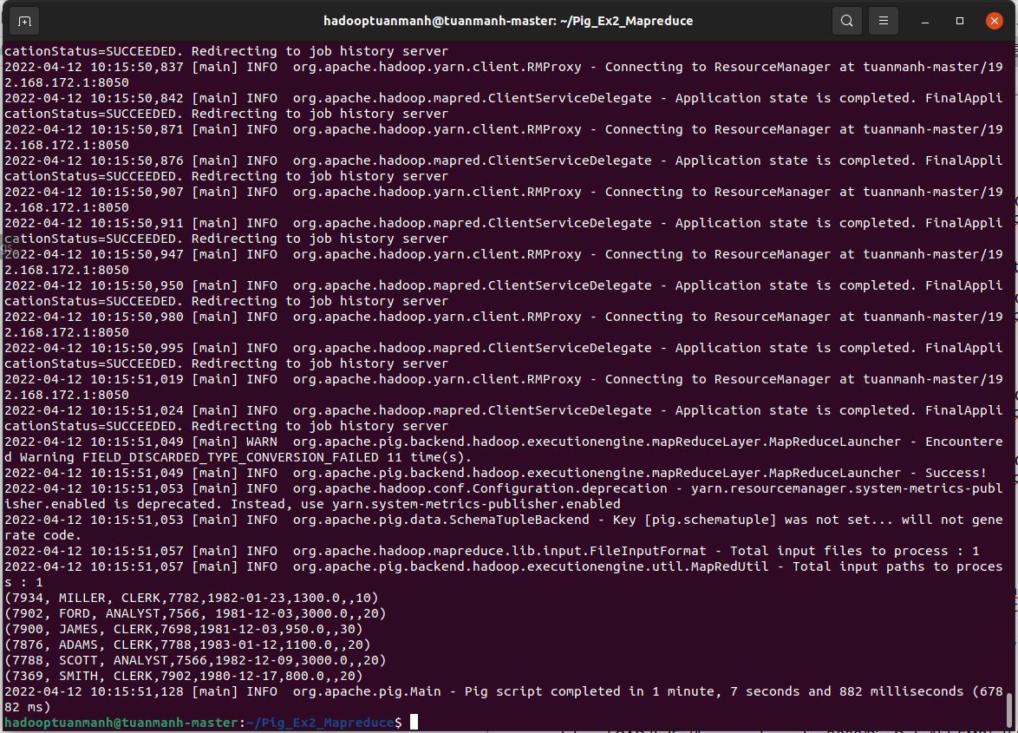

## Bài 16: [List Employees who joined on 1-May-81, 31-Dec-81, 17-Dec-81, 19-Jan-81](http://howt2talkt2apachepig.blogspot.com/2016/01/16-list-emps-who-are-either-clerk-or.html)

1. Local

* Tạo file ex16.pig



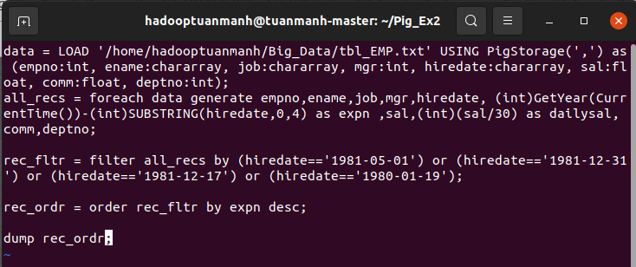

run local mode



Kết quả:

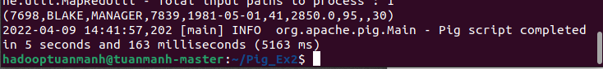

1. MapReduce

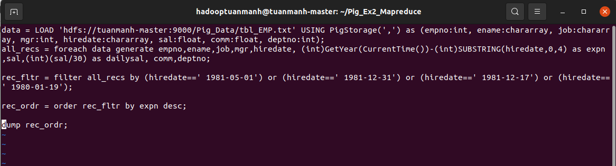



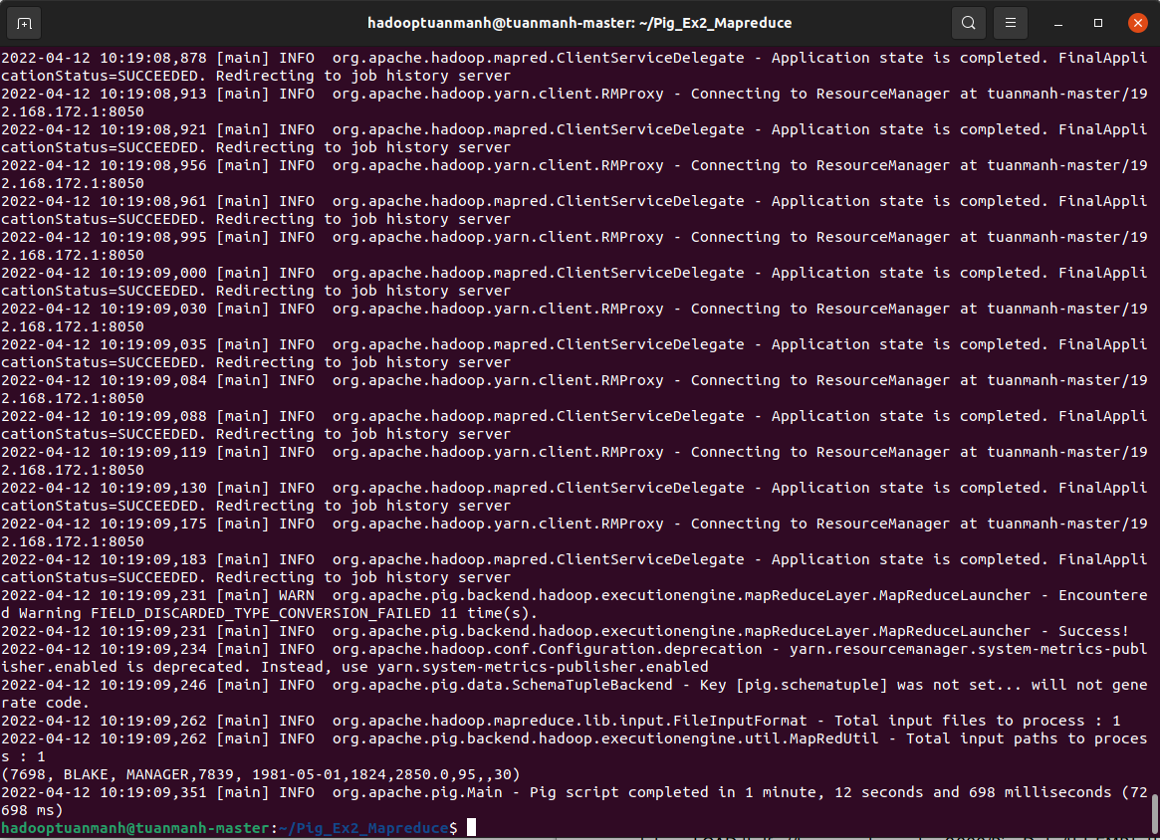

## Bài 17: [List Employees who are working for the deptno 10 or 20](http://howt2talkt2apachepig.blogspot.com/2016/01/17-list-emps-who-joined-on-1-may-81-31.html)

1. Local

* Tạo file ex17.pig



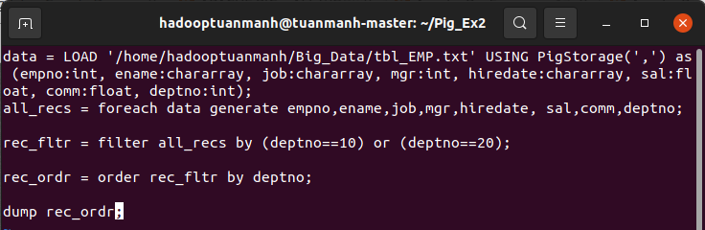



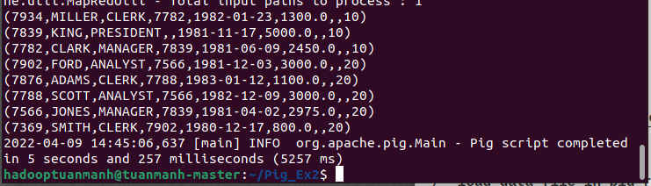

1. MapReduce

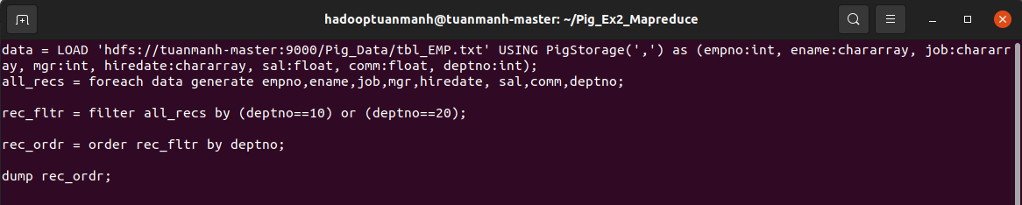



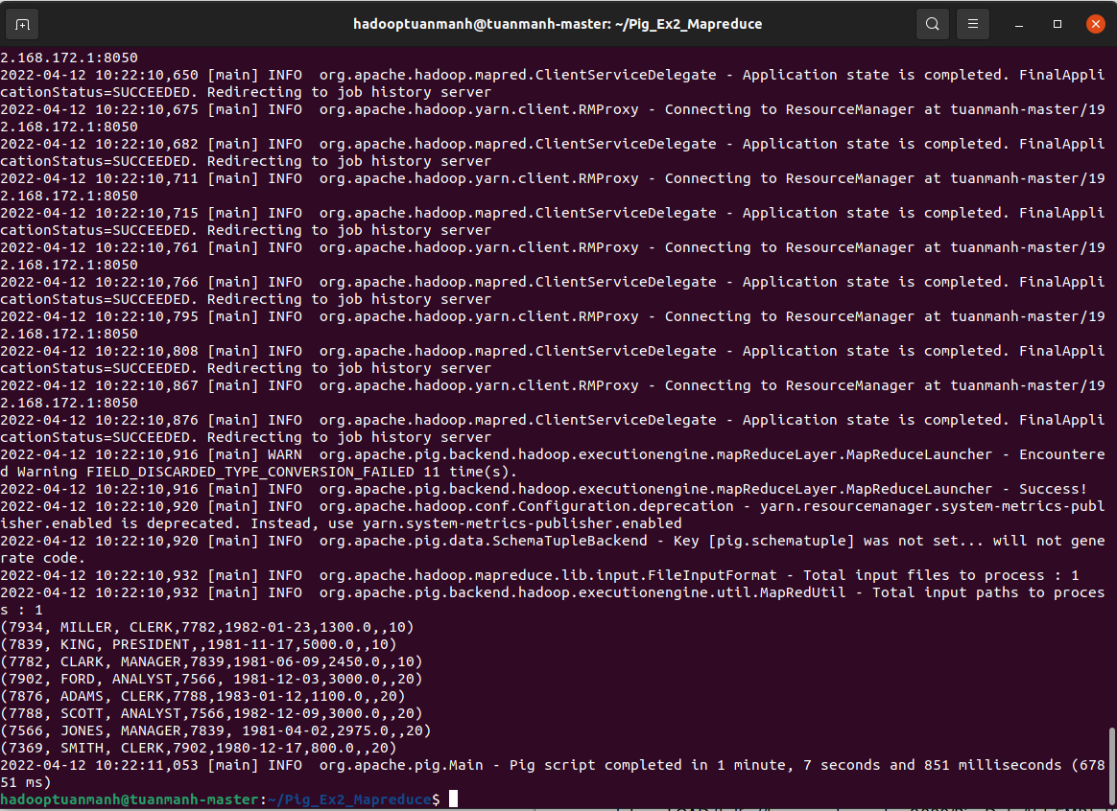

## Bài 18: [List Employees who are joined in the year 1981](http://howt2talkt2apachepig.blogspot.com/2016/01/18-list-emps-who-are-working-for-deptno.html)

1. Local

* Tạo file ex18.pig



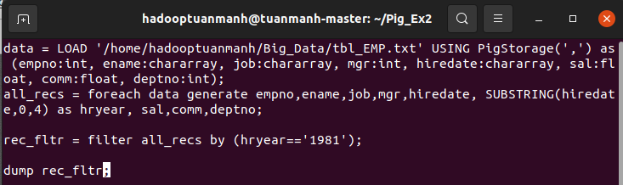



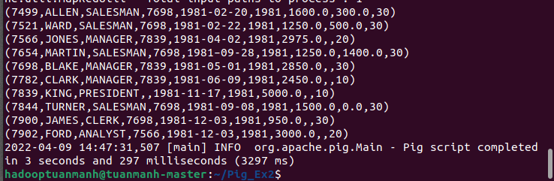

1. MapReduce

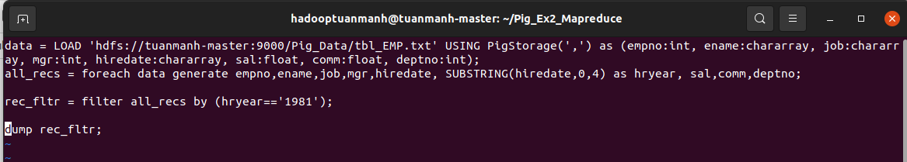



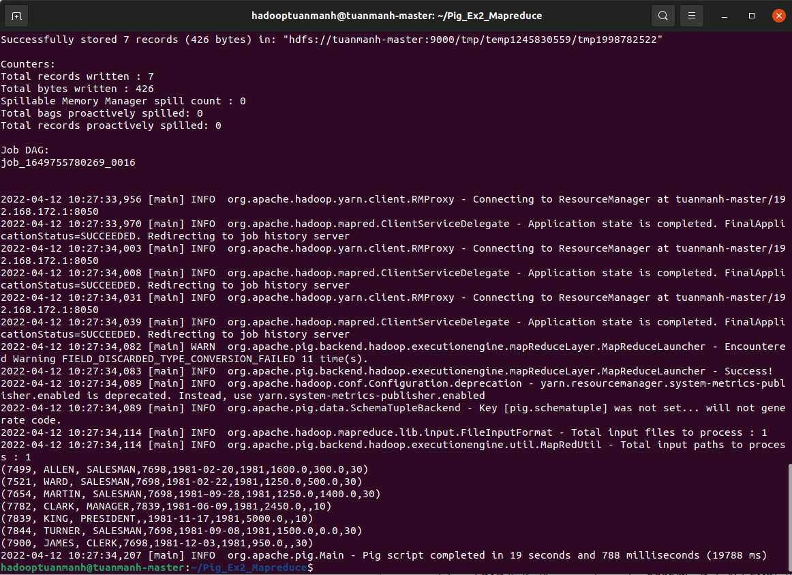

## Bài 19: [List Employees who are joined in the month of Dec 1981](http://howt2talkt2apachepig.blogspot.com/2016/01/19-list-emps-who-are-joined-in-year-1981.html)

1. Local

* Tạo file ex19.pig

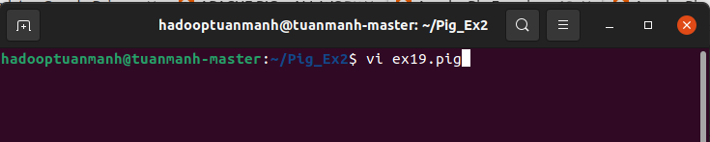

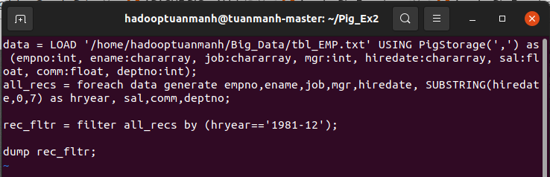



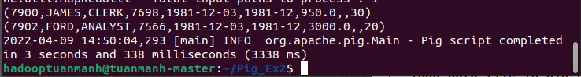

1. MapReduce

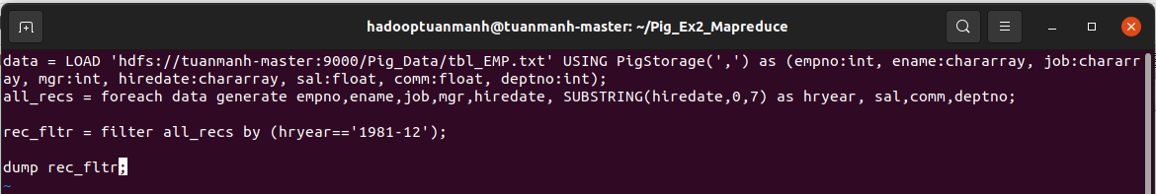

Run mapreduce mode



Kết quả phía dưới:

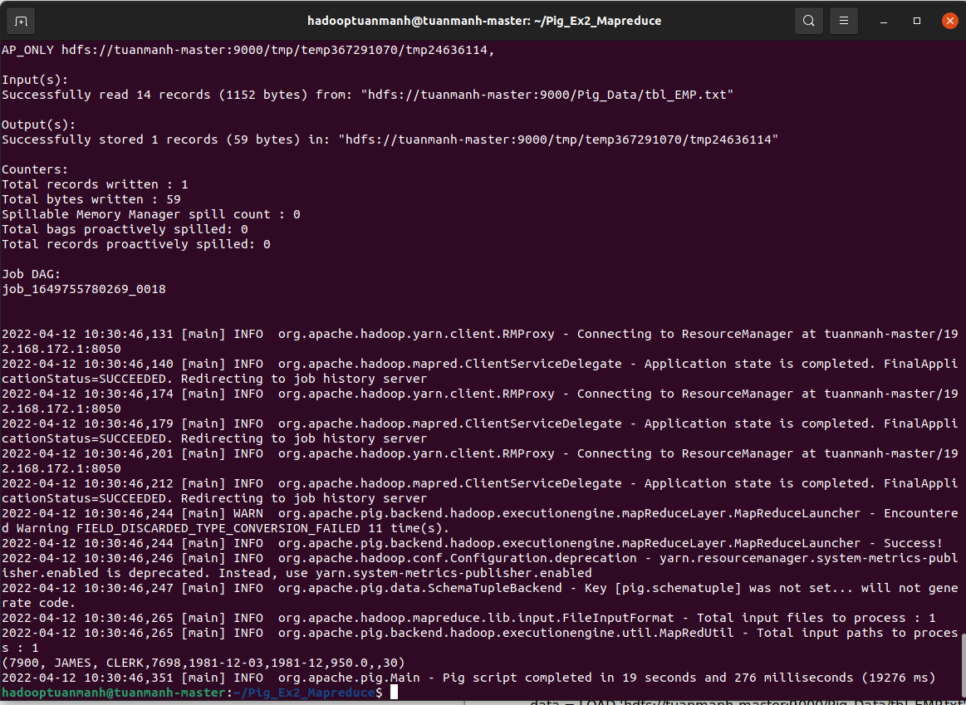

## Bài 20: [List Employees whose annul salary is ranging from 22000 and 45000](http://howt2talkt2apachepig.blogspot.com/2016/01/20-list-emps-who-are-joined-in-month-of.html)

1. Local

* Tạo file ex20.pig



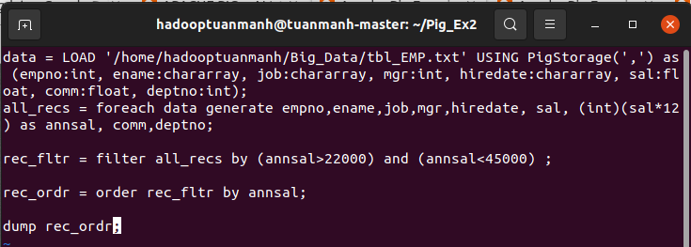



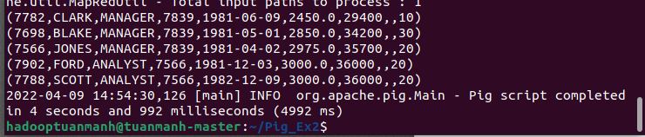

1. MapReduce

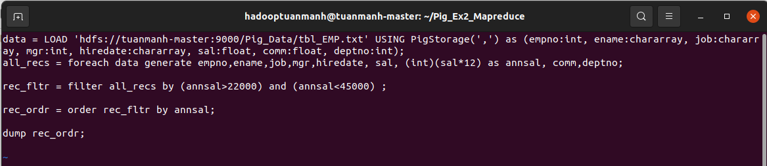

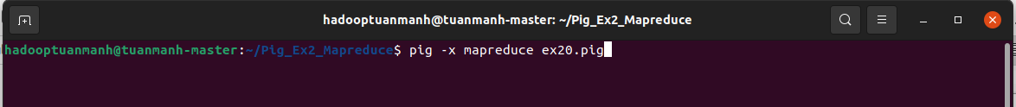

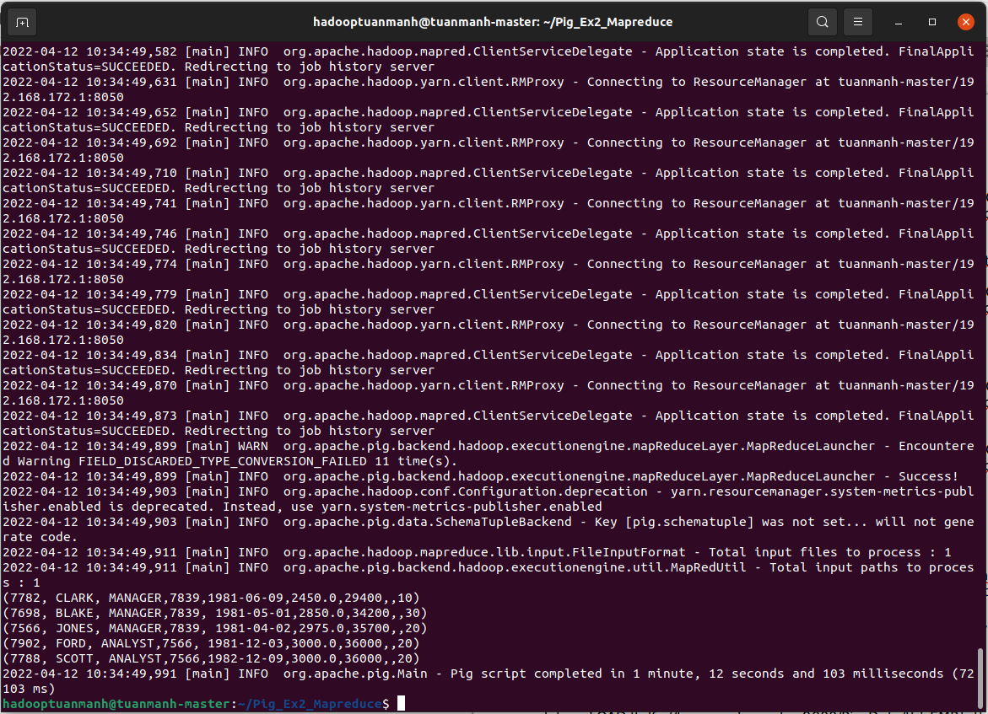

## 

## Bài 21: [List Employees those are having five characters in their names](http://howt2talkt2apachepig.blogspot.com/2016/01/21-list-employees-those-are-having-five.html)

1. Local

* Tạo file ex21.pig



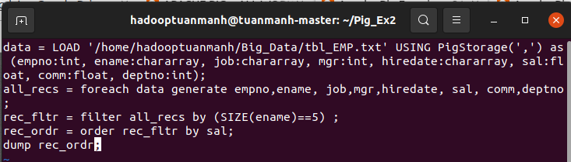



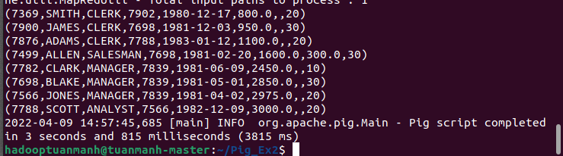

1. MapReduce

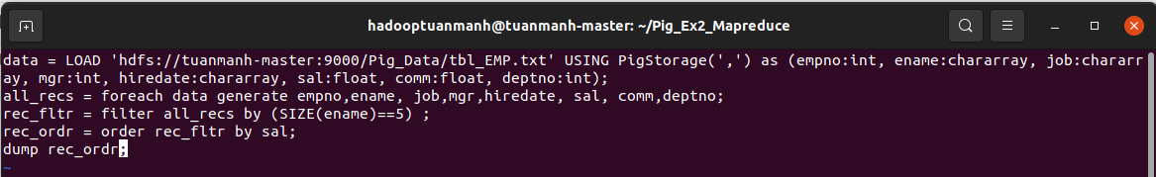

run mapreduce mode



Kết quả phía dưới:

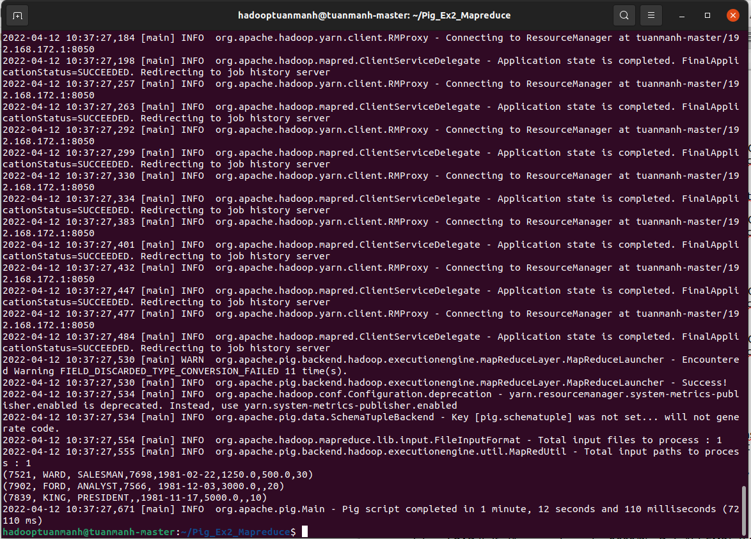

## 

## Bài 22: [List total sales per departmental store wise and consumer wise](http://howt2talkt2apachepig.blogspot.com/2016/02/apache-pig-exercises-21-find-out.html)

1. Local

* Tạo file ex22.pig



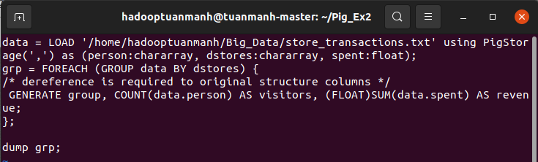



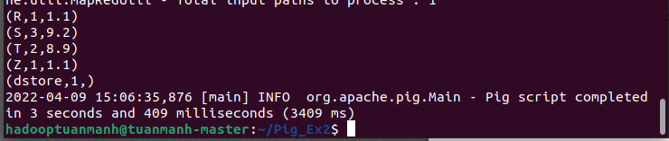

b) MapReduce

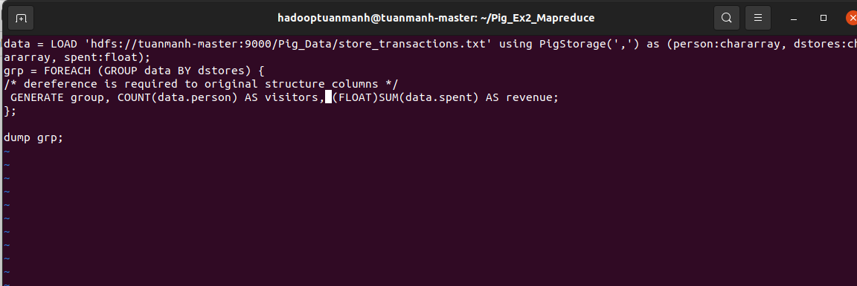

Run mapreduce mode



Kết quả:

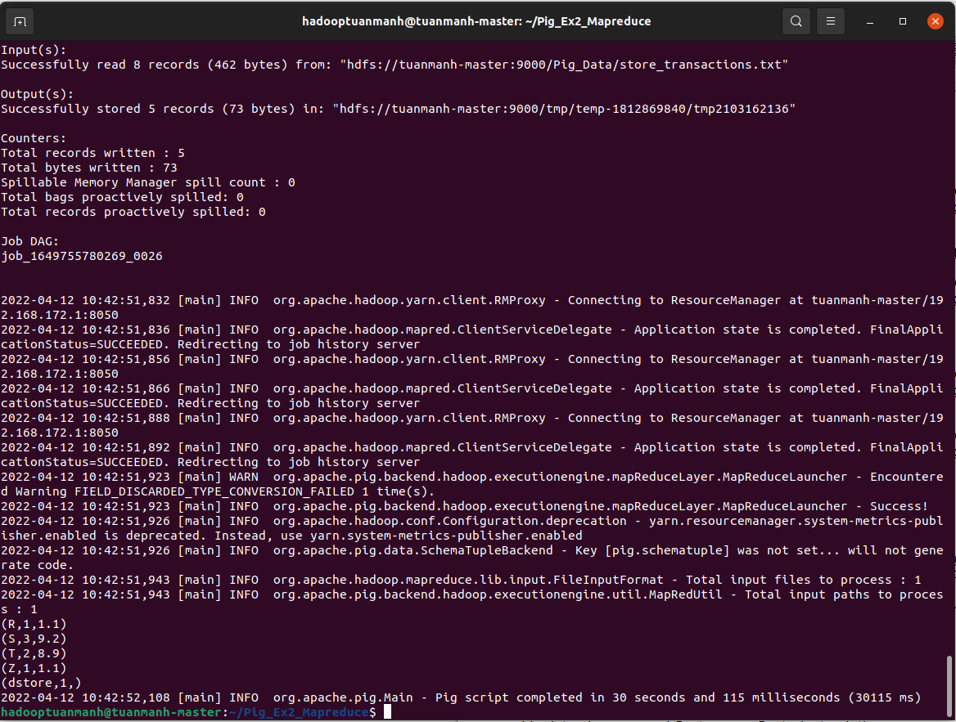

## 

## Bài 23: [How to handle Nulls in data (workaround)](http://howt2talkt2apachepig.blogspot.com/2016/03/apache-pig-exercises-23-how-to-handle.html)

1. Local

* Tạo file ex23.pig



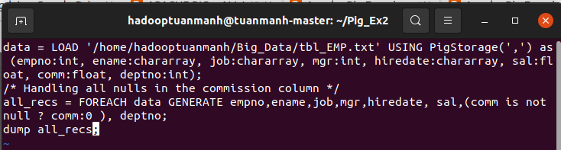



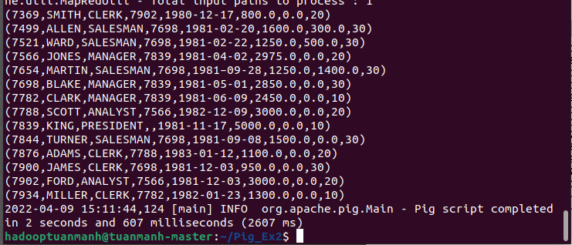

1. MapReduce

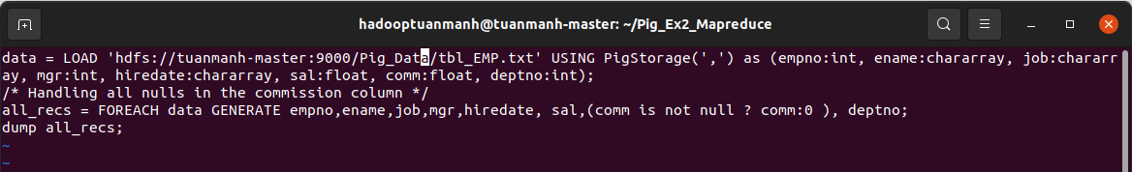

run mapreduce mode



Kết quả:

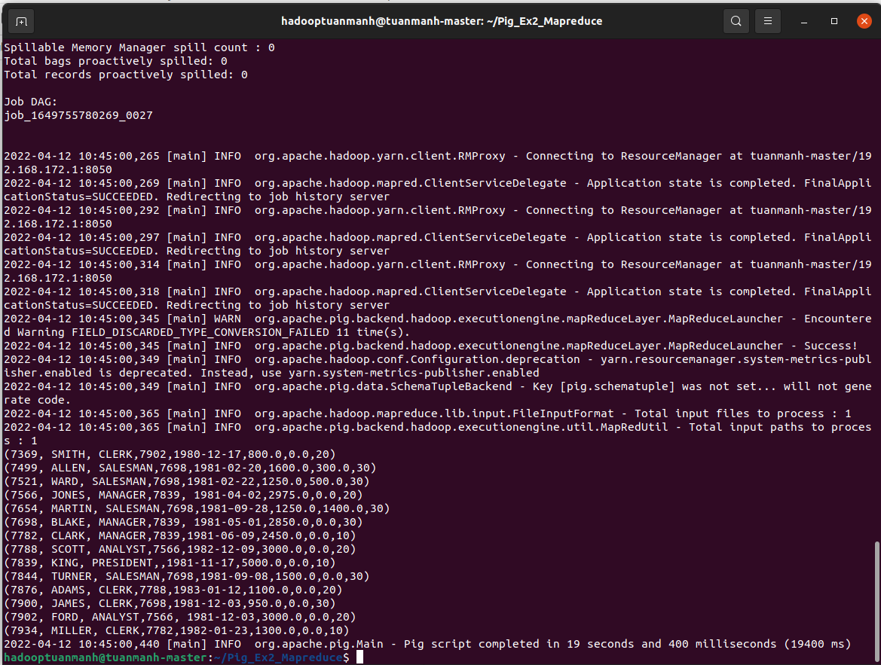

## Bài 24: [24 List Odd or Even Employee records based on empno](http://howt2talkt2apachepig.blogspot.com/2016/03/apache-pig-exercises-24-list-odd-or.html)

1. Local

* Tạo file ex24.pig



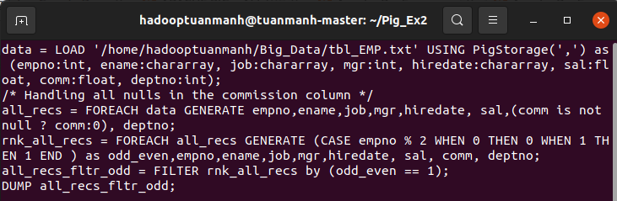



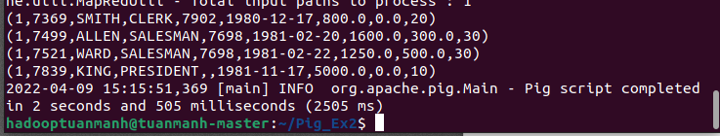

1. MapReduce

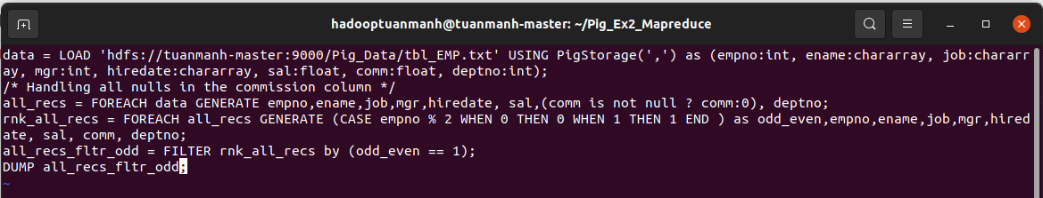

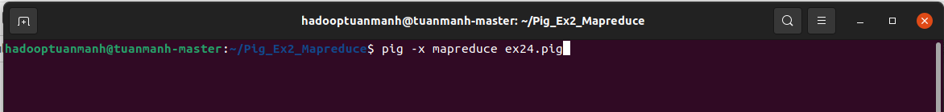

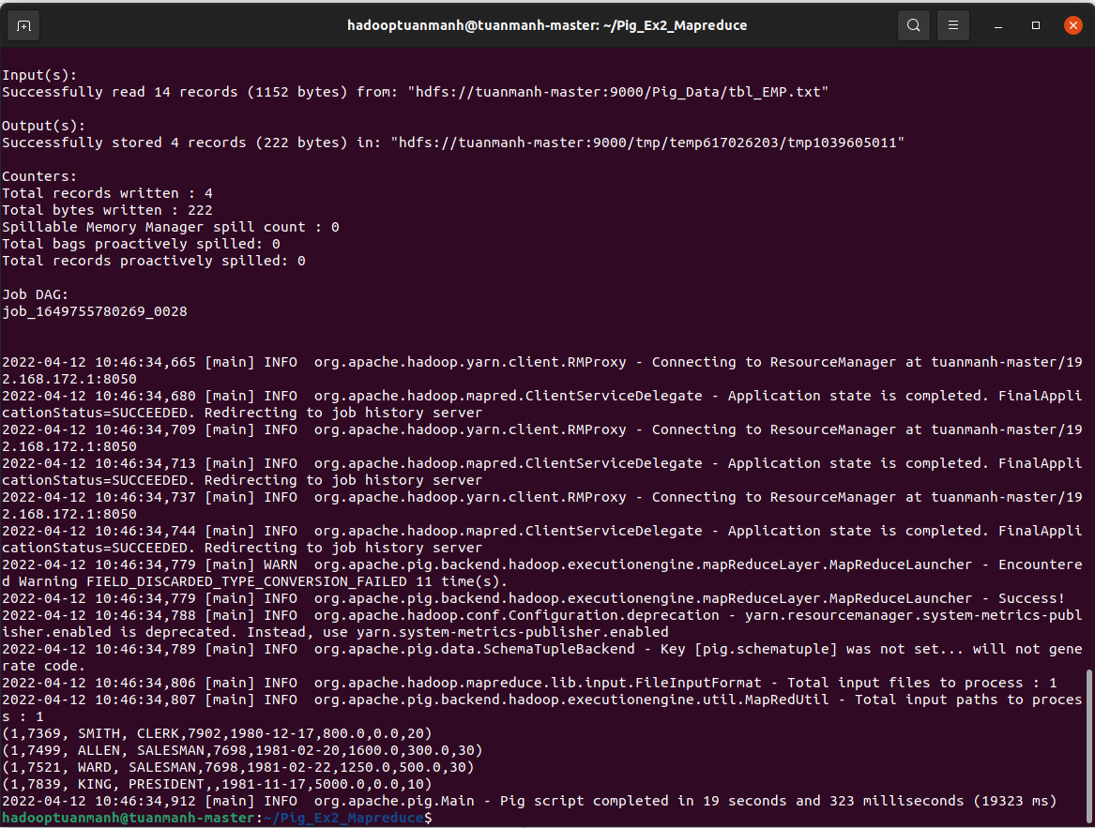

## Bài 25: [List Employee names starting with ‘S’ and having five](http://howt2talkt2apachepig.blogspot.com/2016/04/apache-pig-exercises-25-list-employee.html)

## [characters](http://howt2talkt2apachepig.blogspot.com/2016/04/apache-pig-exercises-25-list-employee.html)

1. Local

* Tạo file ex25.pig



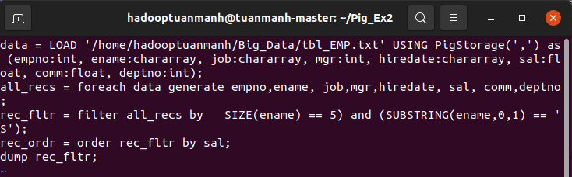



Kết quả:

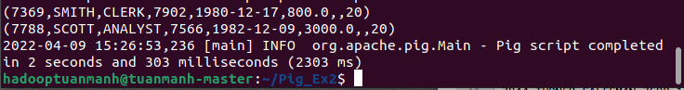

1. Mapreduce

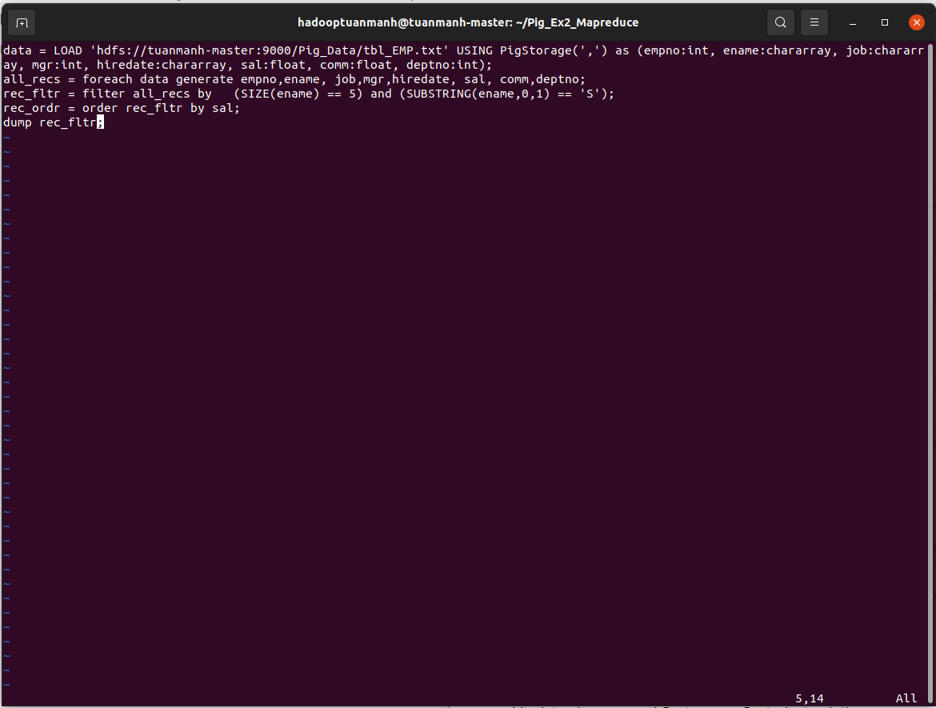



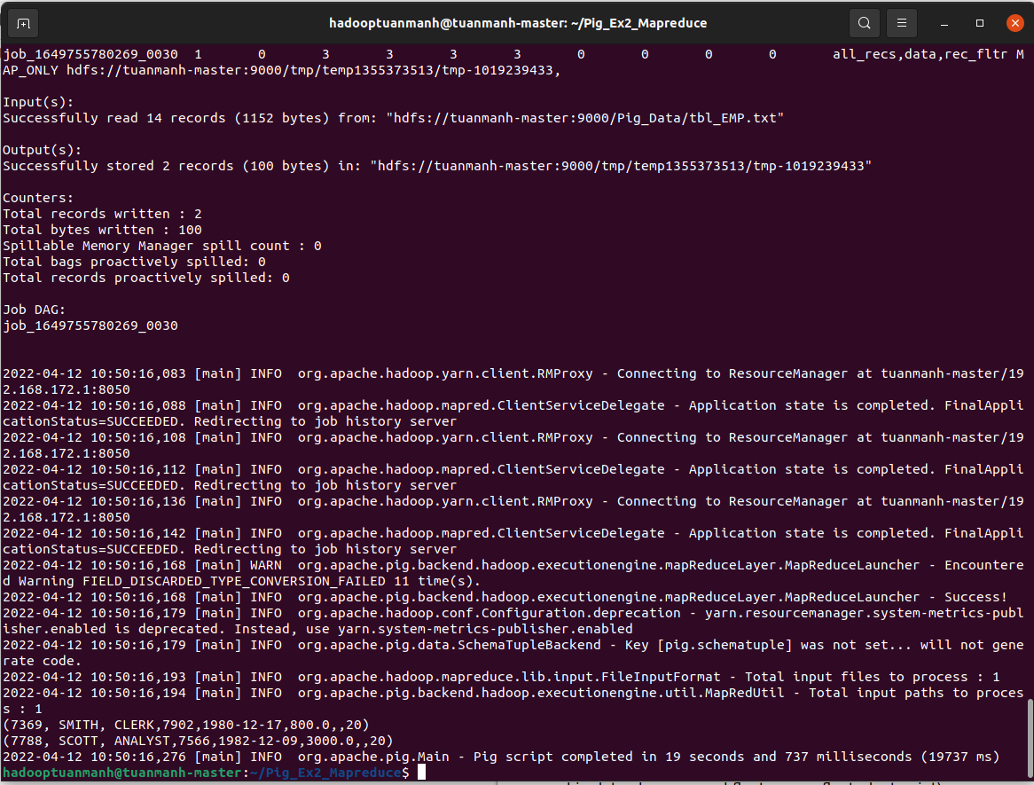

## Bài 26: [List Employee names with 3rd character as ‘R’ and Four characters length](http://howt2talkt2apachepig.blogspot.com/2016/04/apache-pig-exercises-26-list-employee.html)

1. Local



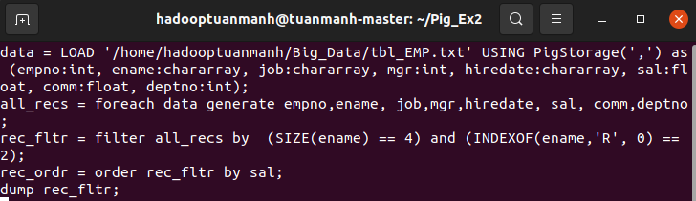



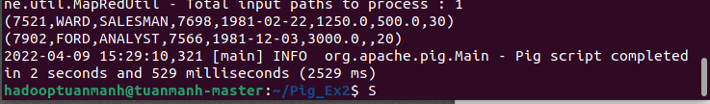

1. MapReduce

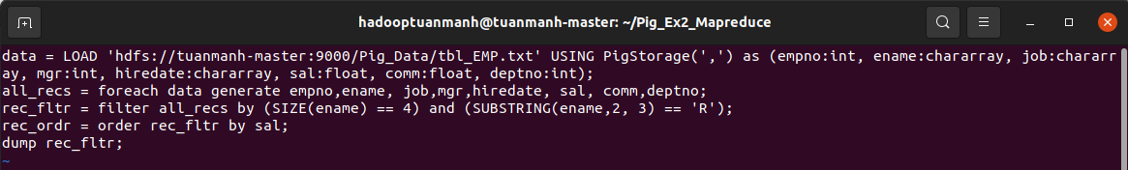

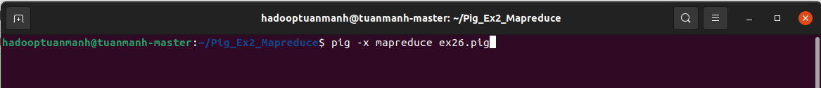

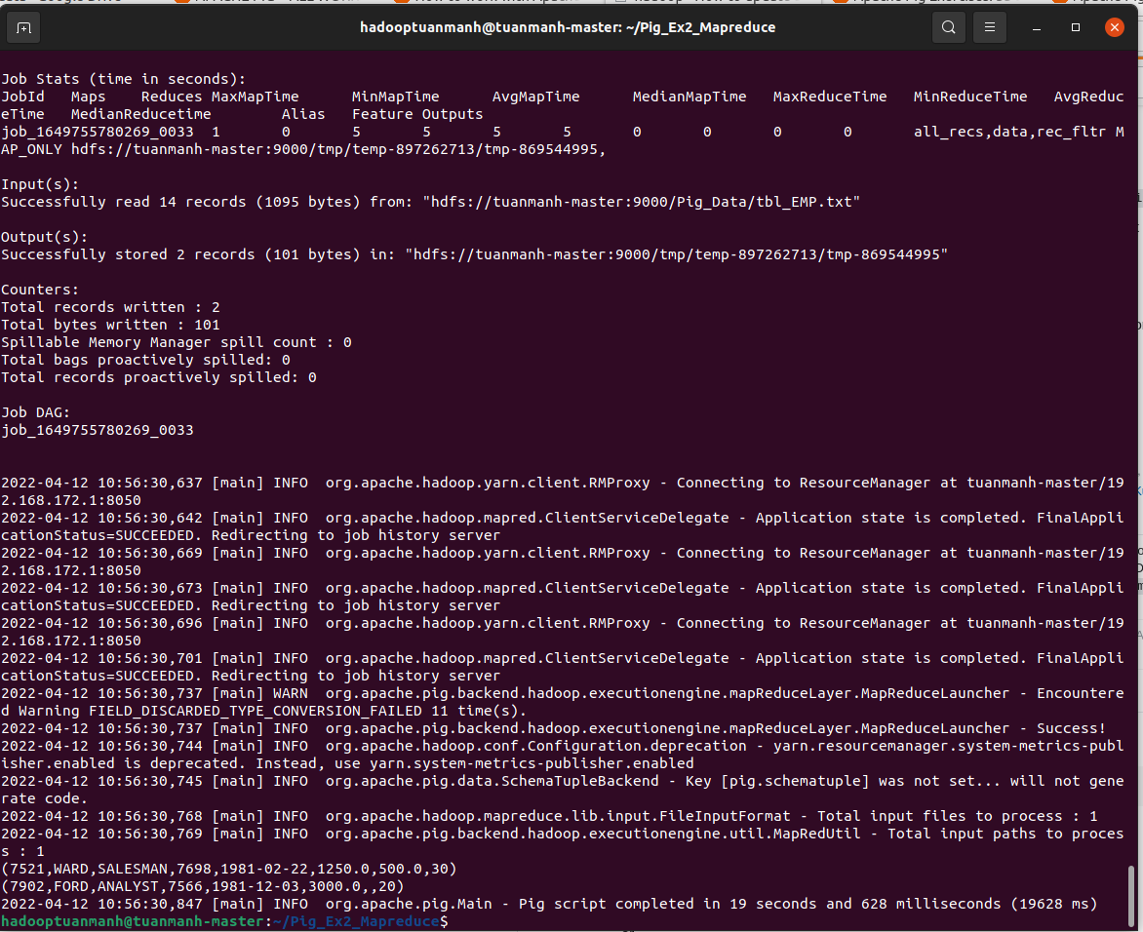

## 

## Bài 27: [List Employee names starting with 'S' and ending 'H' with 5 characters length](http://howt2talkt2apachepig.blogspot.com/2016/04/apache-pig-exercises-27-list-employee.html)

1. Local



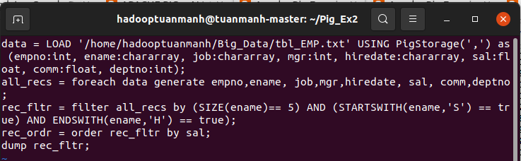





1. MapReduce

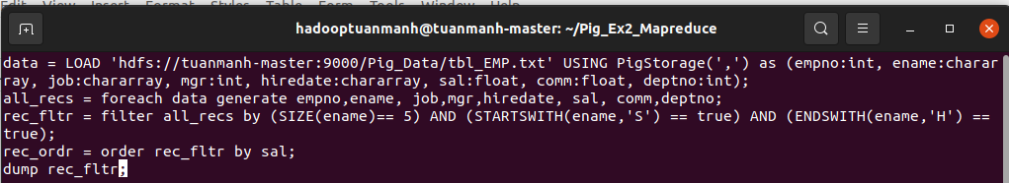



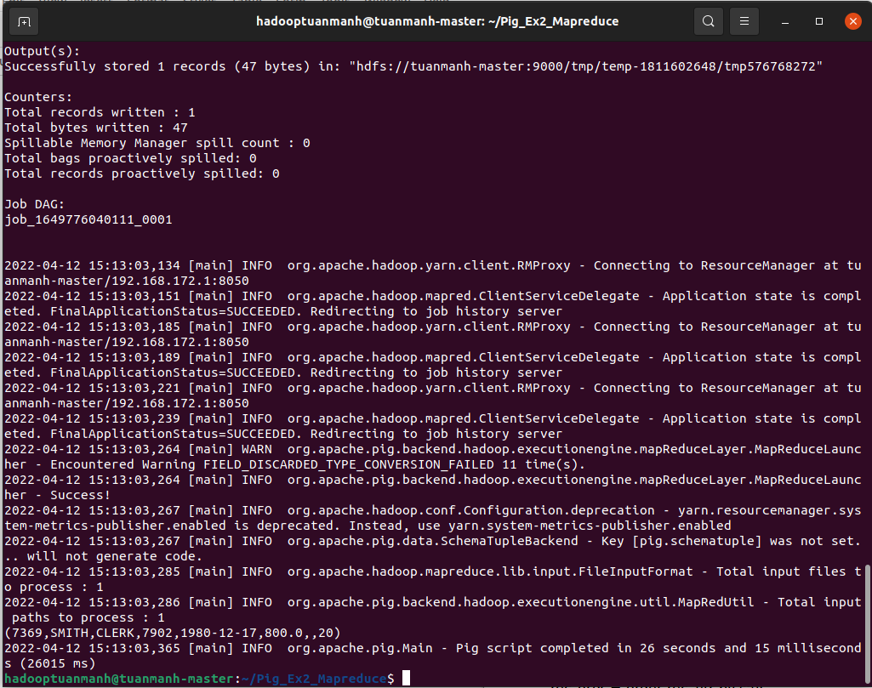

## Bài 28: [List all employees who were joined in January](http://howt2talkt2apachepig.blogspot.com/2016/04/apache-pig-exercises-28-list-all.html)

1. Local



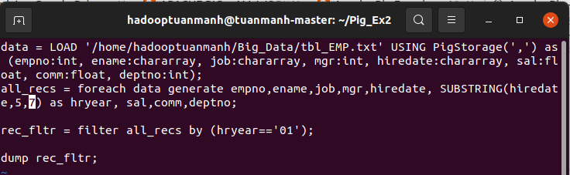



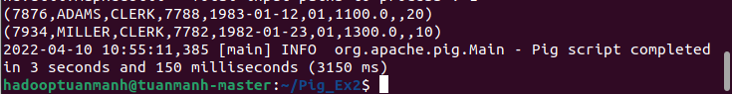

1. Mapreduce

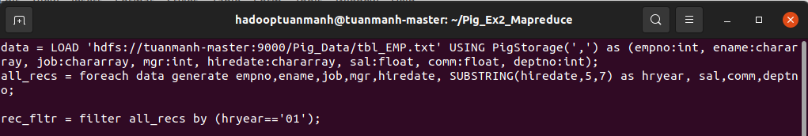



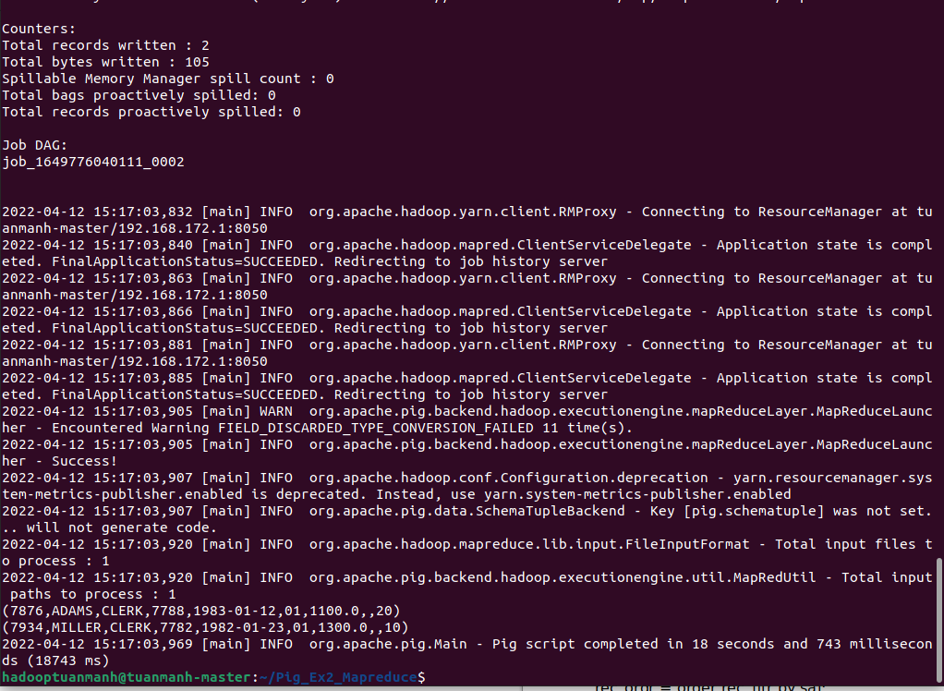

## Bài 29: [List employees who joined in a month of which second character is ‘a’](http://howt2talkt2apachepig.blogspot.com/2016/04/apache-pig-exercises-29-list-employees.html)

1. Local



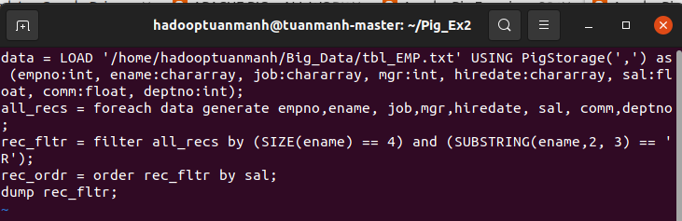



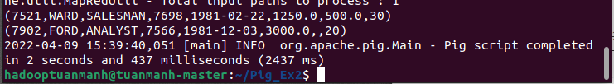

1. MapReduce

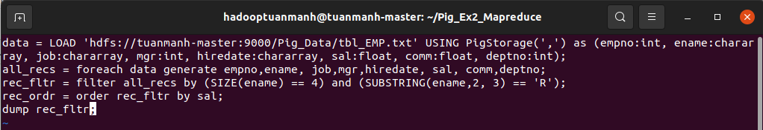



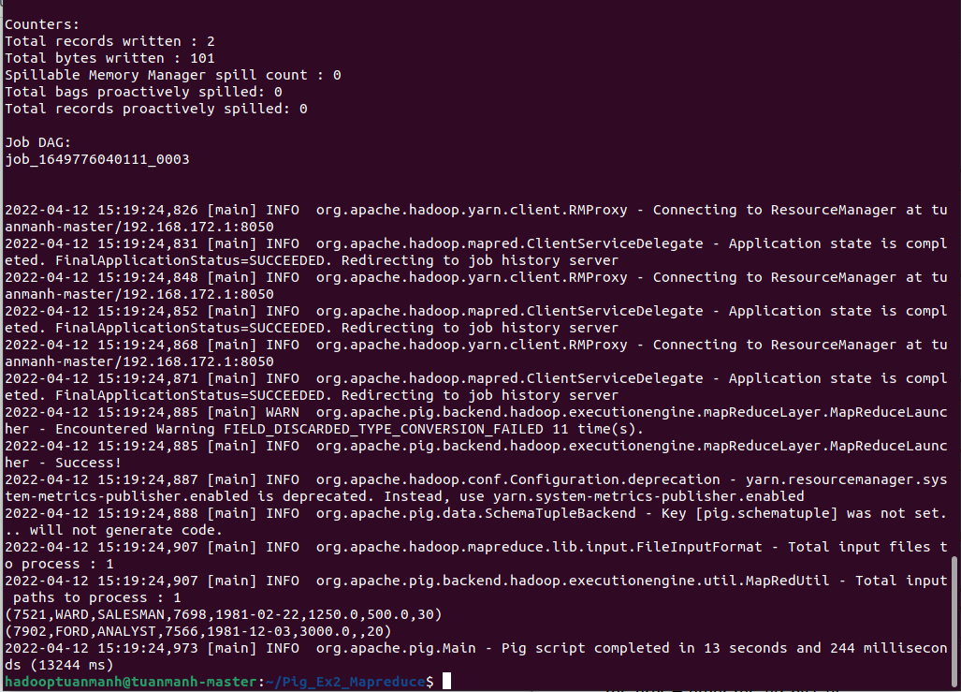

## 

## Bài 30: [List employees whose salary is 4 digit number ending with zero](http://howt2talkt2apachepig.blogspot.com/2016/04/apache-pig-exercises-30-list-employees.html)

1. Local



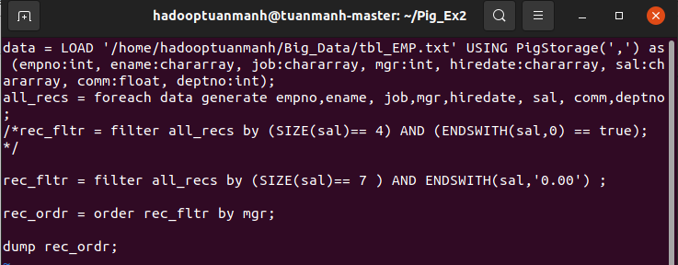



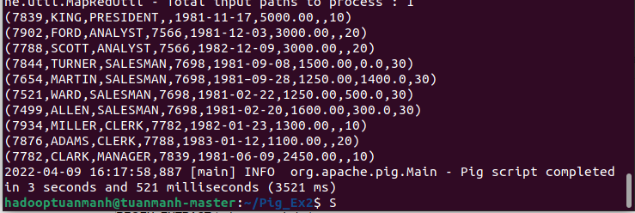

1. MapReduce

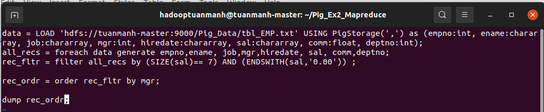



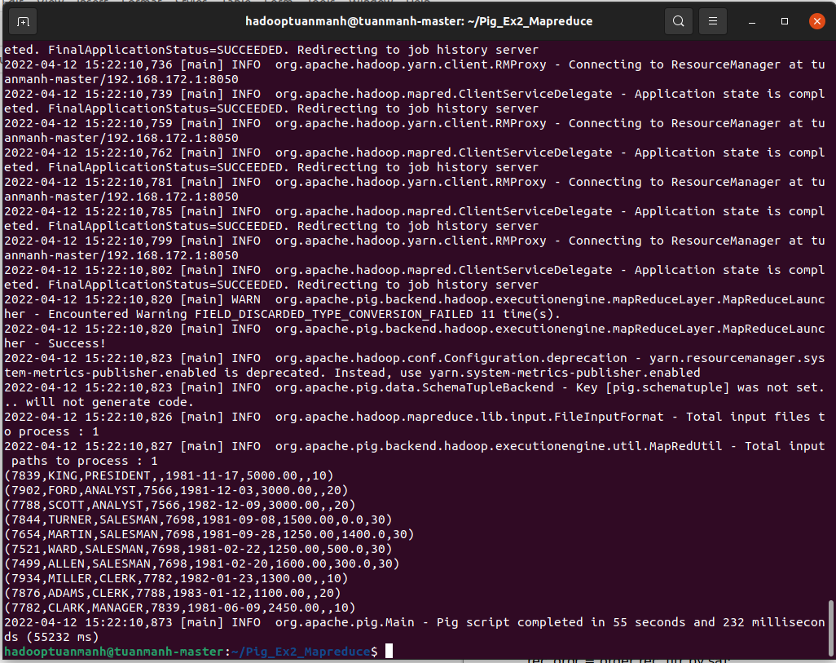

## 

## Bài 31: [List employees whose names have a ‘LL’ characters together](http://howt2talkt2apachepig.blogspot.com/2016/04/apache-pig-exercises-31-list-employees.html)

1. Local



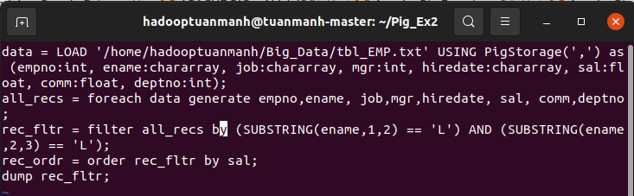



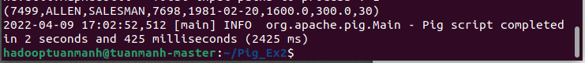

1. MapReduce

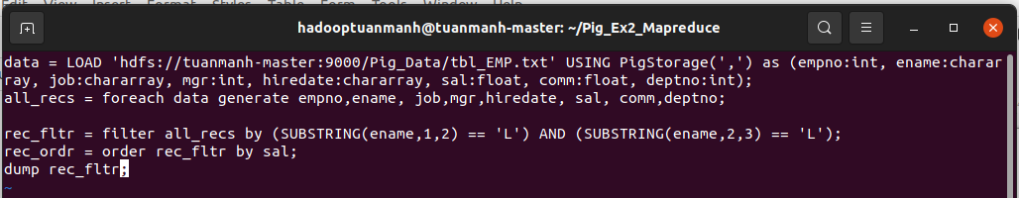



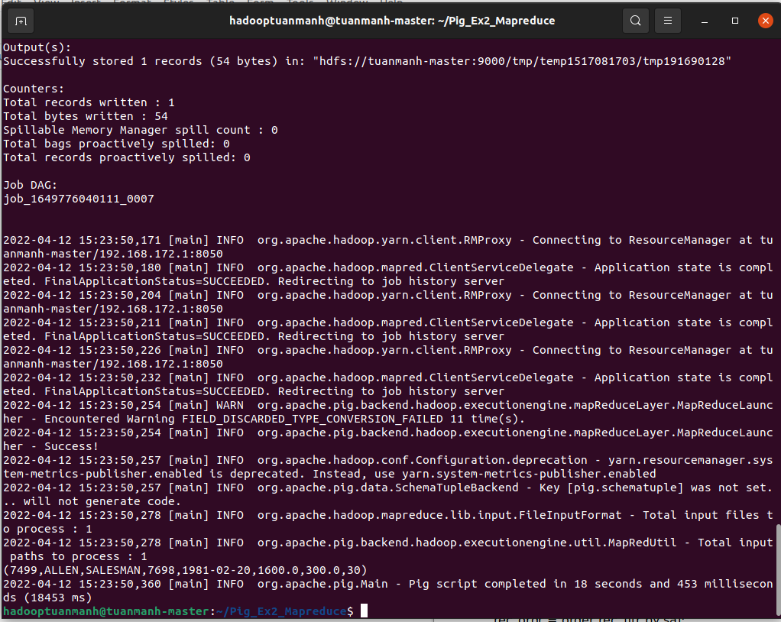

## Bài 32: [List employees who does not belong to deptno 20](http://howt2talkt2apachepig.blogspot.com/2016/04/apache-pig-exercises-32-list-employees.html)

1. Local



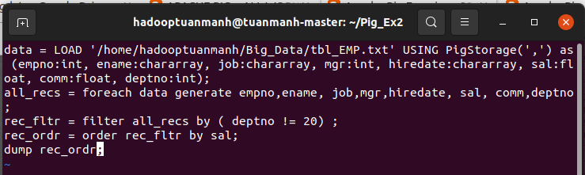

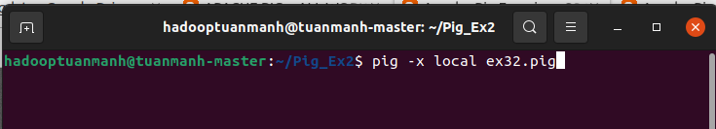

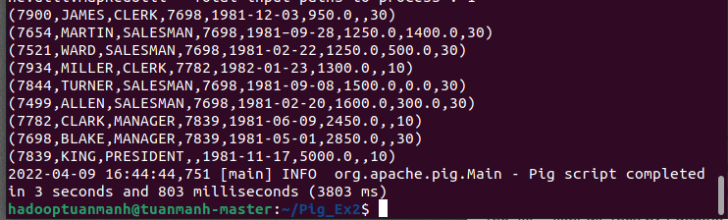

1. MapReduce

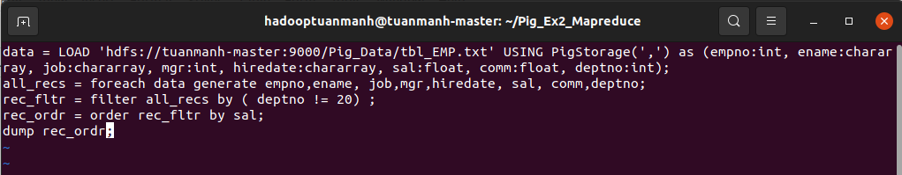

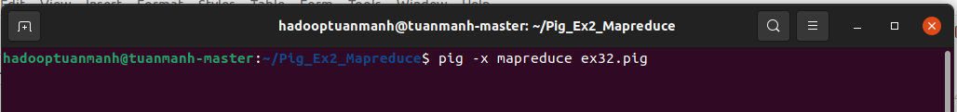

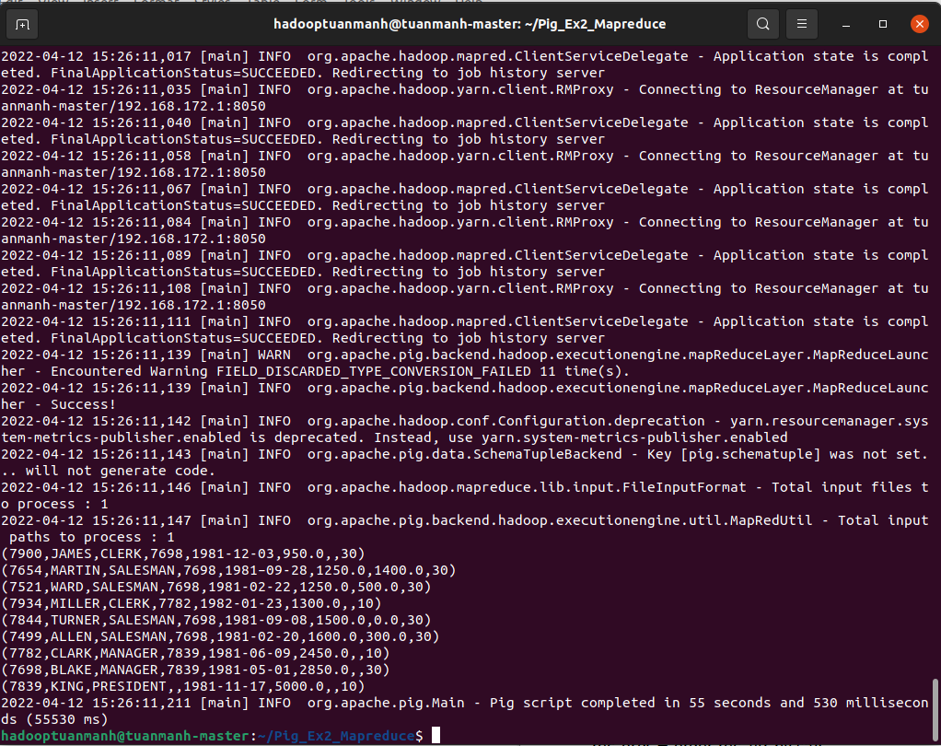

## Bài 33: [List all employees except ‘President’ & ‘Manager’ in asc order of salaries](http://howt2talkt2apachepig.blogspot.com/2016/04/apache-pig-exercises-33-list-all.html)

1. Local



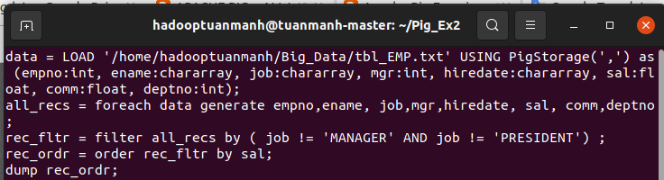

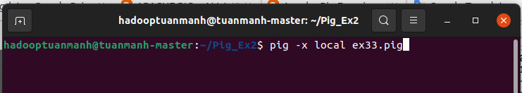

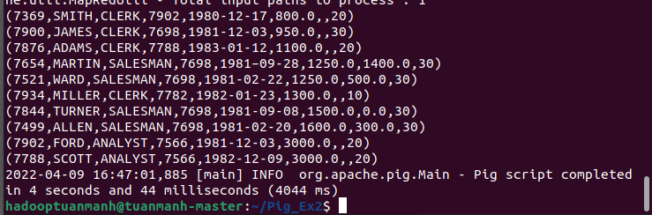

1. MapReduce

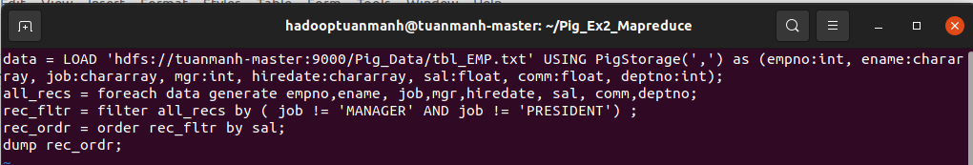



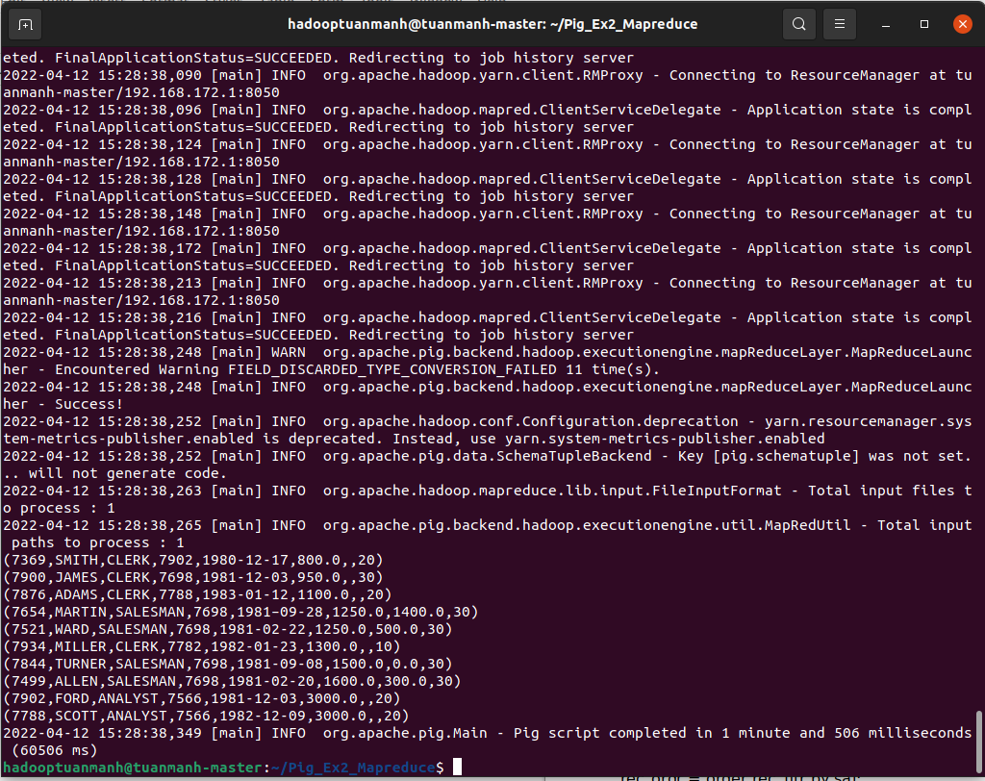

## 

## Bài 34: [List all employees who joined in Before or After 1981](http://howt2talkt2apachepig.blogspot.com/2016/04/apache-pig-exercises-34-list-all.html)

1. Local

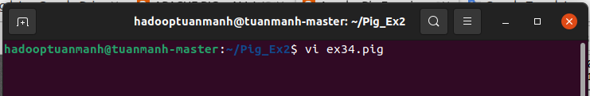

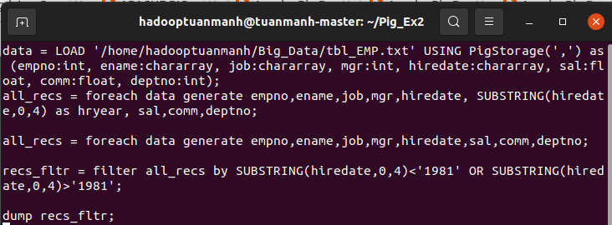



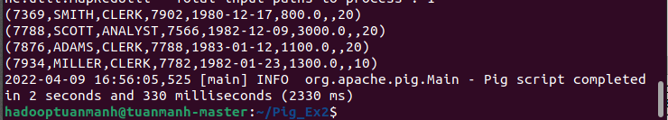

## 

## MapReduce

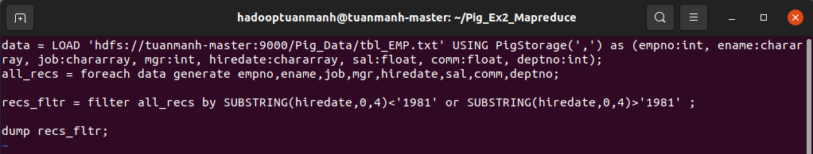



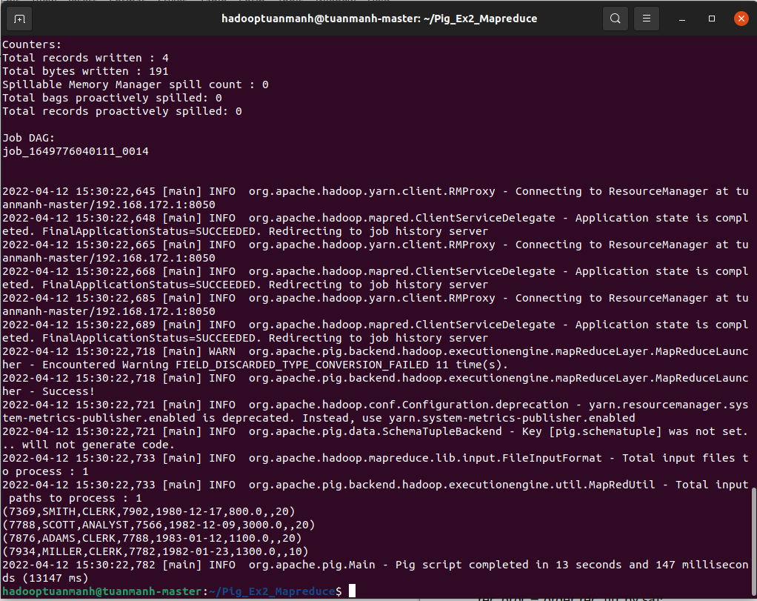

# Pig Eval Functions

### Val



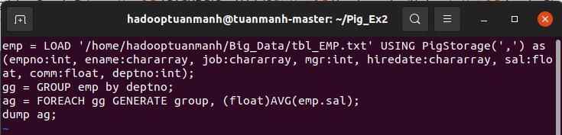



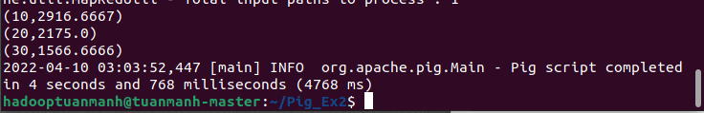

* Mapreduce

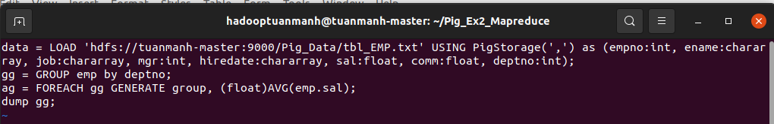



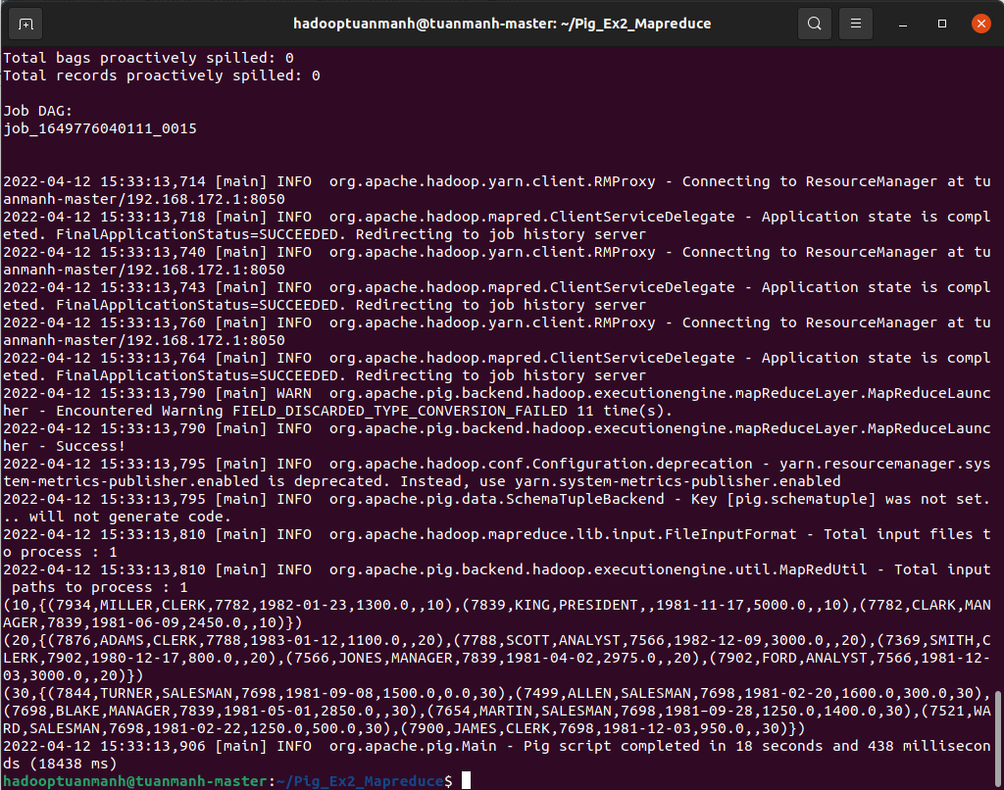

### FOREACH

Local



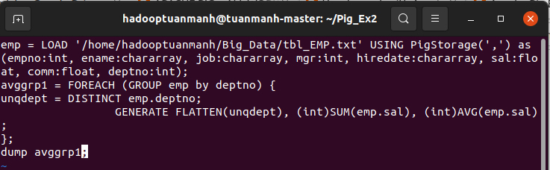



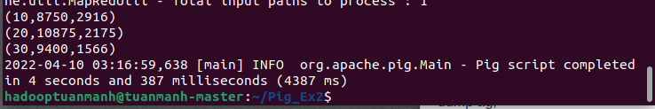

* MapReduce

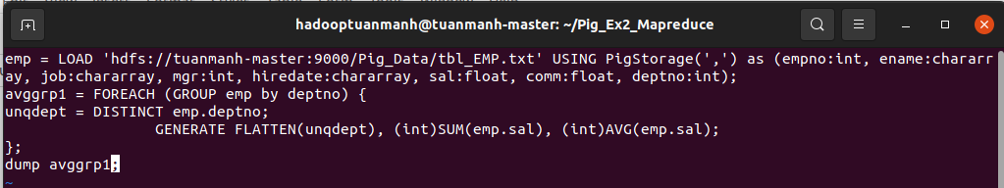



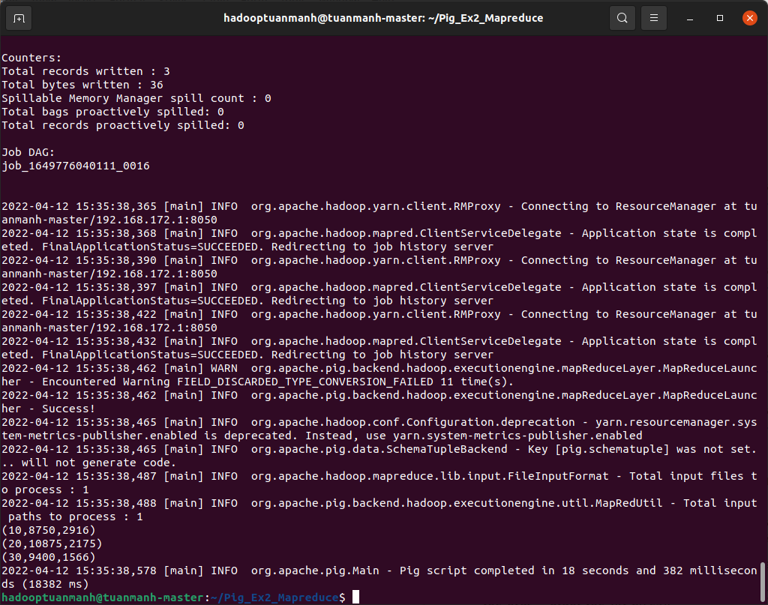

### Bad To String



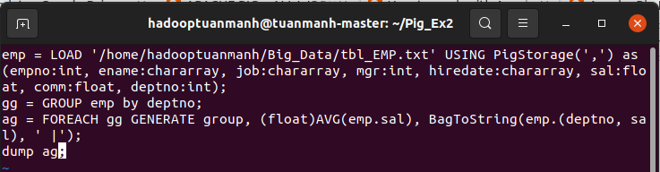



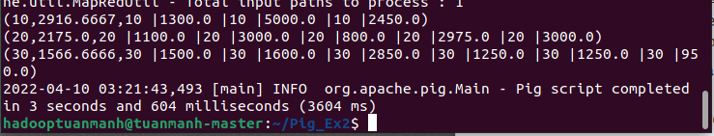

* MapReduce

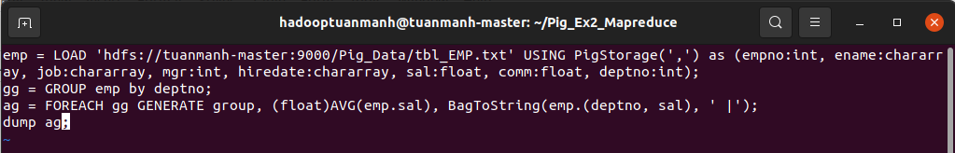



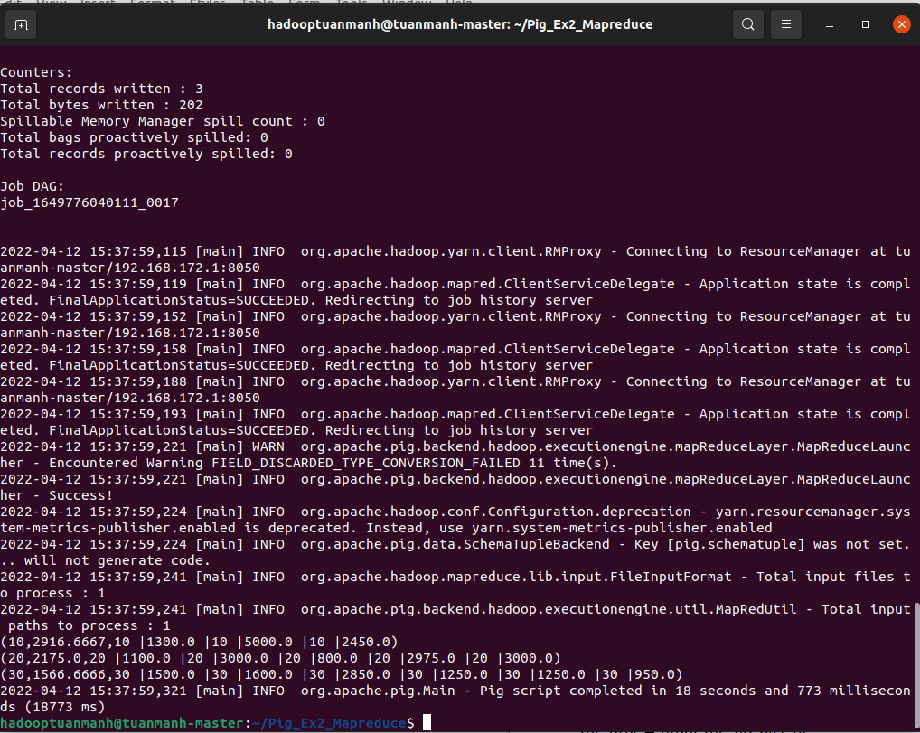

### CONCAT

* local



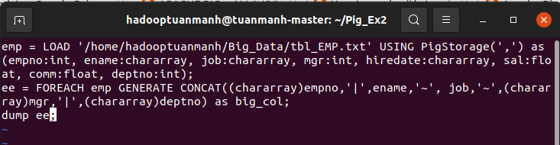



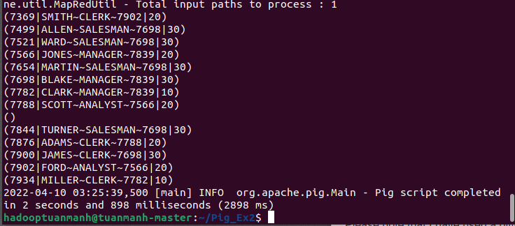

* MapReduce

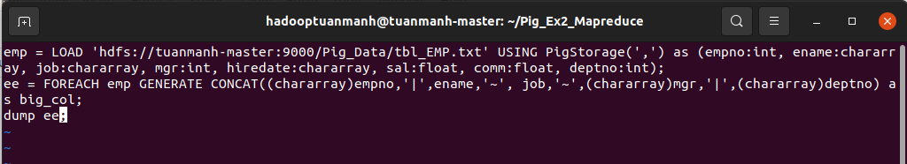



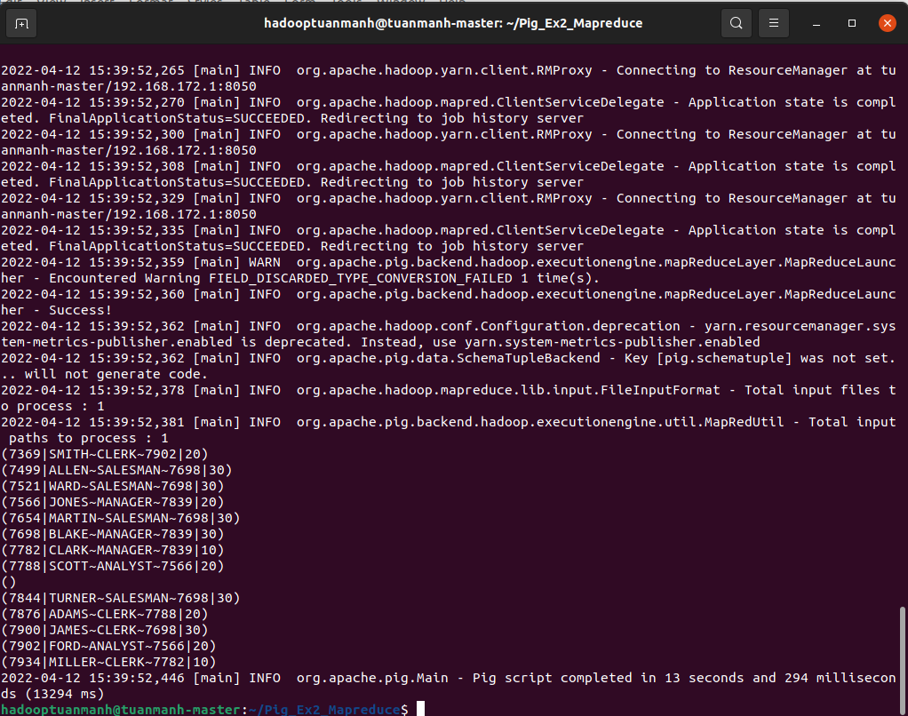

### COUNT



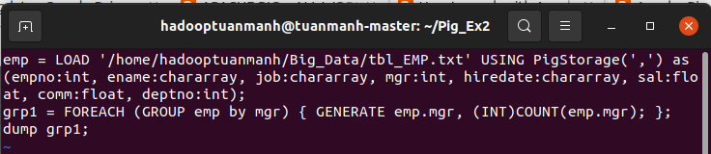



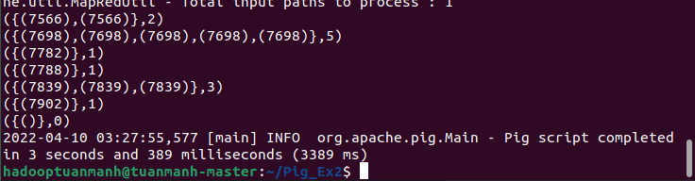

* MapReduce

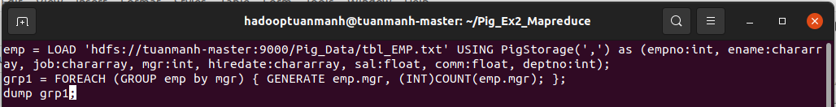



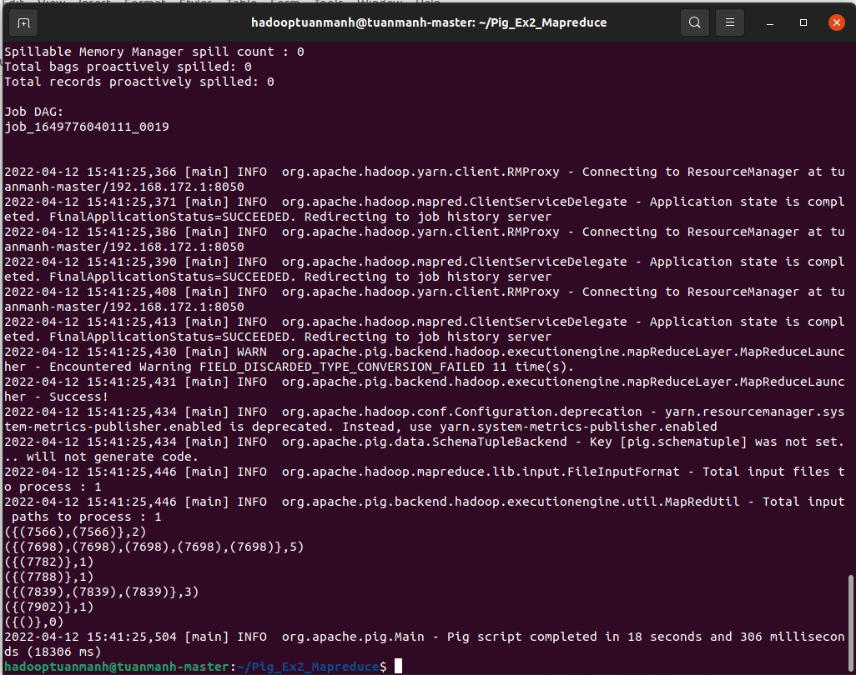

### COUNT STAR



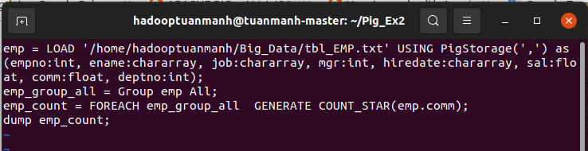

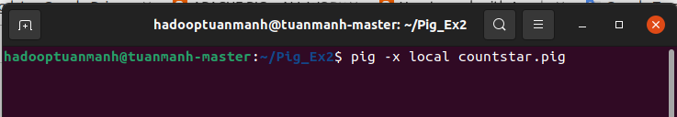

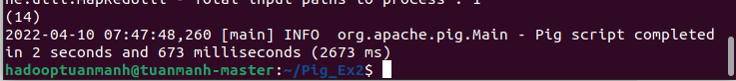

* MapReduce

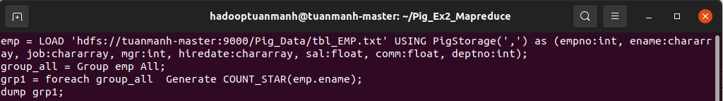



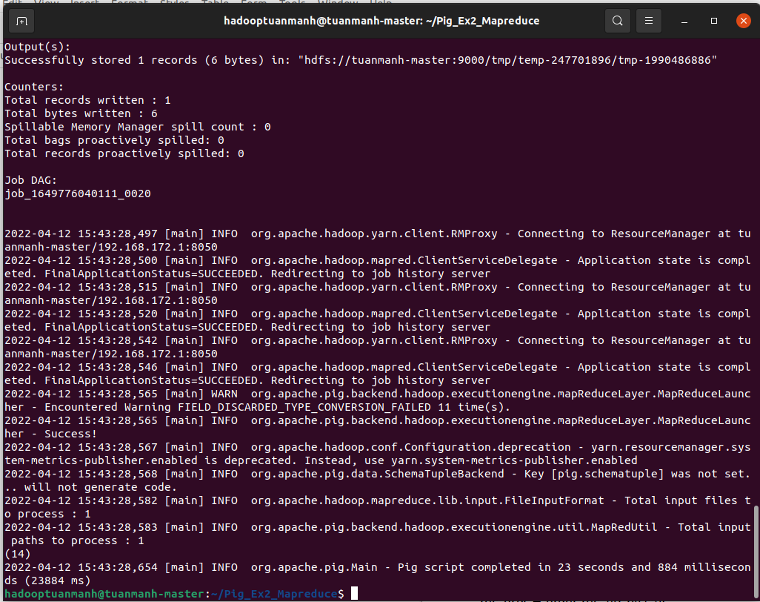

### 

### DIFF

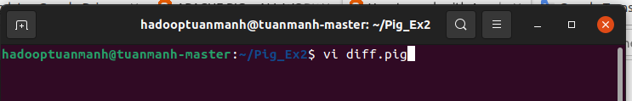

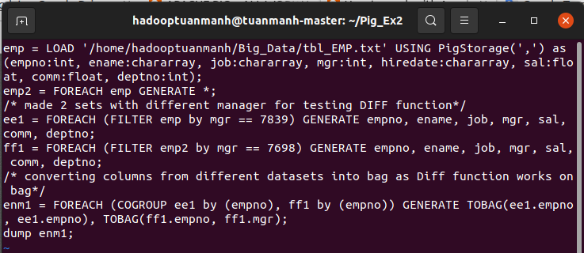



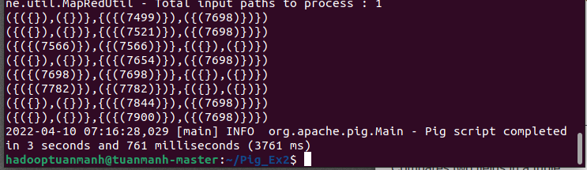

* MapRedcue

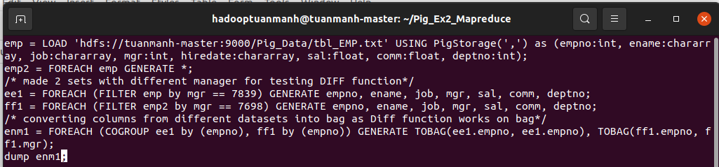



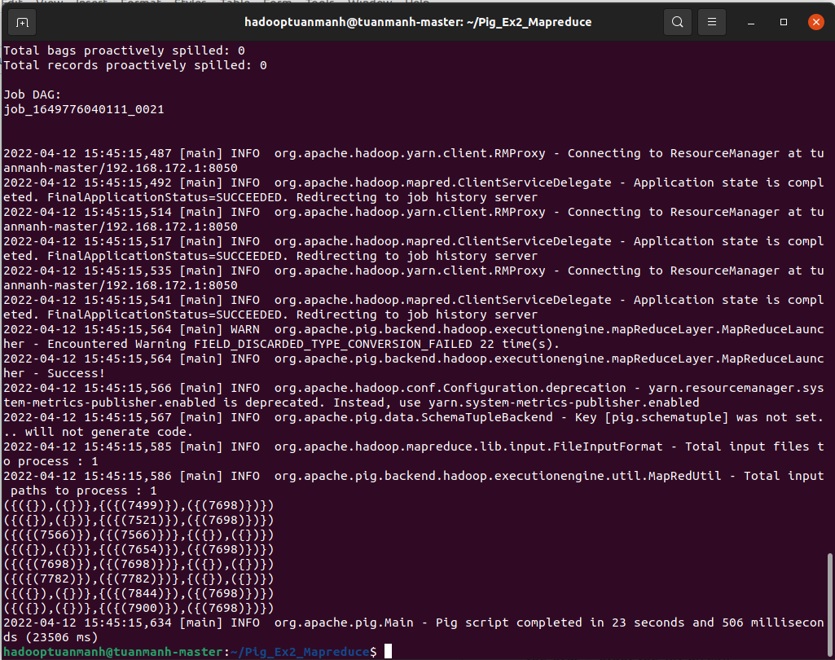

### isEmpty



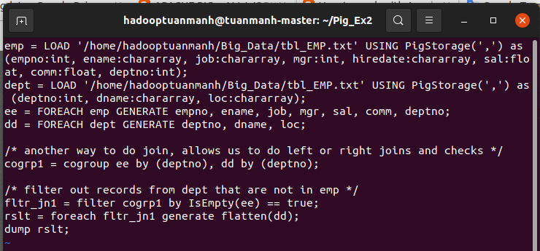



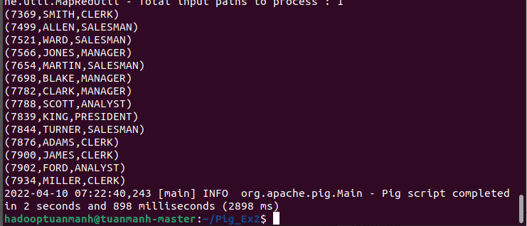

* MapReduce

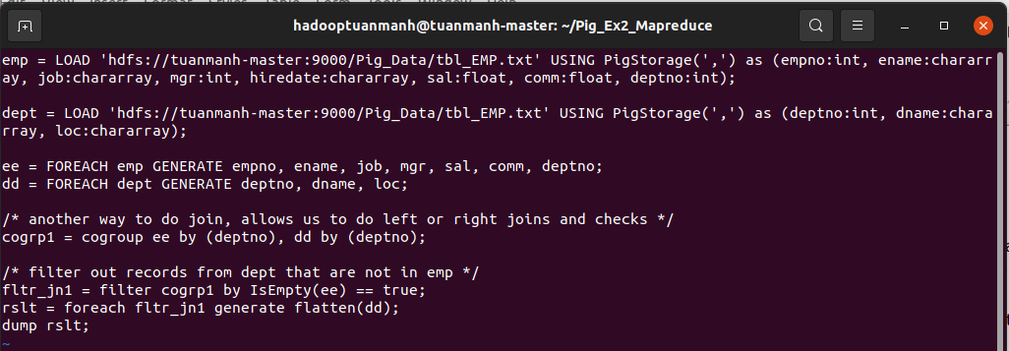



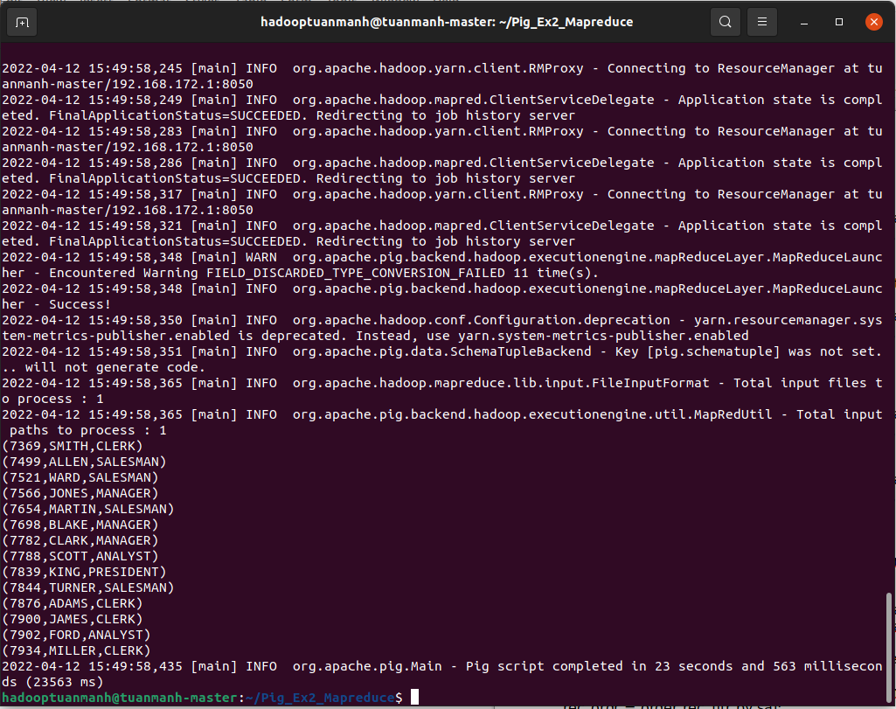

### Max/Min



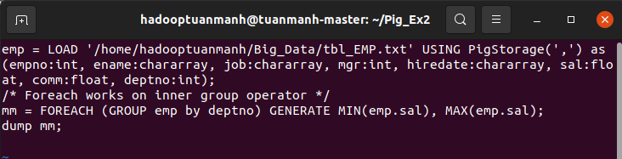



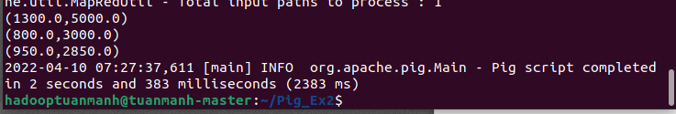

* MapReduce

